

[Document title]

[Document subtitle]



[Date]

[Company name]

[Company address]

University of Petra

faculty of Information technology

graduation project final Documentation

smart hospital bed

prepared by:

Alaa Arab 201411211

Ghada aljibouri 201210913

Fahed Shtawi 201411234

Hamzeh Mahmoud 201420334

Supervised by:

Dr. Mattar

Date:

2017/2018

Second Semester

Faculty of Information Technology

March 9, 2018

Graduation Project Abstract

**RE: Smart patient bed! Project**

Injuries could be various and Sometimes critical that injured person must not be moved or lift by who is not highly trained where one of the most dangerous threats to an injured person is unnecessary movement. Moving an injured person can cause additional injury and pain, and may complicate the victim’s recovery, If the person has a spinal injury it can cause them to be permanently paralyzed and in many hospitals, there is always al lack of trained first responders, which compels doctors to rely on untrained nurse or even ask help from Cleaners to move the injured person from bed to bed or to move bed from the patient room to surgery room.

Here where our project is seeking an optimal way to move the patient form the bed where he is to a 4-wheels auto driven bed using mechanical slides.

The auto driven bed will follow a line on the floor using IR sensors linked from the patient’s room to the surgery room, the bed is also controllable by gesture where the nurse can where glove in his hand and by aiming his hand forward the bed will move forward and so on.

In the front and the back of the bed there are two ultra-sonic sensors to pause the bed when there is an obstacle in the way of the bed, when that obstacle is removed the bed will continue its movement. It is also provided with a light sensor will allow the bed to turn on its build-in light in when the main power goes off and the fact that it works on batteries makes it able to supply other necessary monitoring equipment with power.

When the bed in rest mode it will be plugged to a smart solar panel fixed on the top of the roof of the hospital and what makes these panels smart that they follow the sun light using servo and light sensors.

Moreover, there is a heat sensor fixed to the bed where it measures Patient temperature and alert the doctor by starting off buzzer sound.

In the surgery room the doctor has the ability to adjust the high of the bed by pressing a button that will start a scissor jack.

To make the project more useful a website will be developed to give the doctors the ability to store night shift medical doses and some basic information about the patient, the website will also include the user manual of the bed, some necessary documentation and help and maintenance.

The hardware will be connected and programmed using Arduino technology and Arduino ide. The website will be developed using php language.

1.PROJECT INITIATION 2

1.1 Problem Definition 2

1.2 Current / Existing Systems 3

1.2.1 The Smart Hospital Bed (Existing System) 3

1.2.2 Flexbed (Existing System) 3

1.2.3 A semi-autonomous motorized mobile hospital bed (Existing System) 3

1.2.4 Normal hospital bed (Current System) 4

1.3 Literature Review. 5

1.3.1 Introduction 5

1.3.2 Autonomous Robots 5

1.3.3 An Intelligent Robotic Hospital Bed for Safe Transportation of Critical Neurosurgery Patients Along Crowded Hospital Corridors(FLEXBED) 7

1.3.4 Arduino Mega 2560 8

1.3.5 Lm393 Motor Speed Measuring Sensor Module 9

1.3.6 Conclusion 10

1.4 Project Objectives 11

1.5 Stakeholder List 11

1.6 Proposed scope and Process model 11

1.7 Scope excluded and project constraints. 12

2.PROJECT PLANNING AND REQUIREMENTS 14

2.1 PLANNING 14

2.1.1 SCOPE INITIATION(WBS) 14

2.1.2 GANTT CHART 17

2.1.3 RESOURCE PLANNING SCHEDULING AND RESOURCE DISTRIBUTIN 20

2.1.4 SYSTEM DEVELOPMENT REQUIRMENT 22

2.1.5 COST ESTIMATING AND BUDGETING. 23

2.1.6 RISK LIST (RISK ANALYSIS). 25

2.2 REQUIRMENTS 26

2.2.1 Requirement elicitation techniques 26

2.2.2 LIST OF FUNCTIONAL AND NON- FUNCTIONAL REQUIRMENTS 26

2.2.2.1 FUNCTIONAL REQUIREMENTS. 26

2.2.2.2 NON-FUNCTIONAL REQUIREMENTS. 27

2.2.3 Use Case Specifications 28

2.2.3.1 Use Case Specifications for SHB. 28

2.2.3.2 Use Case Specifications for website 32

2.2.4 Domain Object Diagram 36

2.3 Result 38

3.Planning and Requirements 44

3.1 use case diagram 44

3.2 Activity Diagram 46

3.3 Sequence Diagram 50

3.4 State Diagram 53

3.5 Class diagram 56

3.6 Component Diagram 58

3.7 Deployment Diagram 60

3.8 Output Layer 61

4.IMPLEMENTATION AND TESTING 65

4.1 website database mapping 65

4.2 Table description 65

4.3 Architecture/technology Description 66

4.4 Algorithm for major functions 67

4.4.1 check distance 67

} 67

4.4.2 move for ward 67

4.4.3 steps to centimeters 69

4.5 Sample code for main functions 69

4.5.1 Glove class 69

4.5.2 BL Class 71

4.6 Test Cases 73

Hardware Datasheet 74

Arduino Due 74

Arduino uno 77

Arduino nano 78

MPU 6050 Gyroscope 79

BLUETOOTH HC-06 80

Ultrasonic sensor 81

References 83

Table of figure

Figure 1 gantt chart 17

figure 2Gannt chart2 18

figure 3 gannt chart 3 19

Figure 4 resource cost overview 24

figure 5task cost overview 25

Figure 6 Domain Object Diagram SHB 36

figure 7 Domain Object Diagram website 37

figure 8 result 1 38

figure 9 Result 2 38

figure 10 result 3 39

figure 11result 4 39

figure 12result 6 40

figure 13 result 5 40

figure 14 result 7 41

figure 15result 8 42

figure 16 result 9 42

figure 17SHB usecase diagram 44

figure 18website use case diagram 45

figure 19 Solar panel activity Diagram 46

figure 20 Gesture control Activity Diagram 47

figure 21create new user 48

figure 22 login Activity Diagram 49

figure 23Solar panel Sequence Diagram 50

figure 24 Glove Sequence Diagram 51

figure 25 user login sequence diagram 52

figure 26 shb automated movement sequence diagram 52

figure 27 smart solar panel state diagram 53

figure 28glove state diagram 54

figure 29 shb state diagram 54

figure 30 night reads state diagram 55

figure 31shb class diagram 56

figure 32 glove class diagram 57

figure 33 solar panel component diagram 58

figure 34 glove component diagram 59

figure 35 Solar Deployment Diagram 60

figure 26 website database mapping 65

figure 27 nightreads table 65

Table of tables

Table 1 stakeholder 11

Table 2Scope part 1 14

Table 3scope part2 15

Table 4 Scope part3 15

Table 5 Scope part 4 16

Table 6 Resource Planning part1 20

Table 7 Resource planning part2 20

Table 8 Resource planning part3 21

Table 9 Resource planning part4 21

Table 10 resource Group 22

Table 11 Cost estimating and budgeting 23

Table 12 risk list 25

CHAPTER 1

# **1.PROJECT INITIATION**

## **1.1 Problem Definition**

Hospital beds are where most patients spend the majority of their time, after all, and new smart beds, help patients stay safe, while smart capabilities help nurses to handle patients case in more efficient way.

Injuries can be various and some could be critical like backbones injury, which requires professional treatment specially when it comes to movement, where one of the most dangerous threats to an injured person is unnecessary movement. Moving an injured person can cause additional injury and pain, and may complicate the victim’s recovery.

Such patients need to be switched between different beds multiple times in order to be transferred between different locations such as an ambulance car, the Intensive Care Unit, and operation theater. The switching of patients with severe head traumas should be performed extremely smoothly and skillfully, therefore, they require up to four specially trained nurses for one patient. Furthermore, although manual pushing/steering is the simplest approach to control the movements of Hospital bed, it is not considered as the most efficient and reliable approach. The most convincing reason is that the performance of the pushing/steering tasks heavily relies on human reactions and decisions, which are subject to various unstable factors such as human concentration on the navigation task and proficiency in operating Hospital beds.

The surgery room is highly sterilized room and to keep it so we should prevent the access of uncleaned people, but this could be hard to achieve with the missing of Certain mechanics to drag the bed in autonomous way.

Another problem is that most of normal patient bed are highly expensive and they come with limited functions where to still need to attach extra devices to monitor patient’s statistics such as heart pulses.

## **1.2 Current / Existing Systems**

### **1.2.1 The Smart Hospital Bed (Existing System)**

This system is developed by Hadramoot team, it’s an Raspberry pi and Windows 10 powered device that transmits patient data to caregivers wherever they are, instantaneously.

contain sensors as temperature sensor heartbeat and pressure sensors and the level of oxygen in the blood and .... etc. All the signals necessary for the supervisor of the patient, the system is located on the bed and tied Sensor. transfer all patient signals, especially cases that need intense care. Signals are sent to the central system at the hospital across the Web in the form of a detailed report the status of the patient during certain periods of time. And in the case of a sudden change of the status of the patient occurrence of the system to send alerts. To the hospital System and Dr. supervisor alerted through the application of Smart mobile bed and the patient's bed issued an audio alert. three alerts be action.

### 

### **1.2.2 Flexbed (Existing System)**

A novel design of an intelligent robotic hospital bed with autonomous navigation ability. The robotic bed is developed for fast and safe transportation of critical neurosurgery patients without changing beds. Flexbed is more efficient and safe during the transportation process comparing to the conventional hospital beds. Flexbed is able to avoid en-route obstacles with an efficient easy-to-implement collision avoidance strategy when an obstacle is nearby and to move towards its destination at maximum speed when there is no threat of collision. We present extensive simulation results of navigation of Flexbed in the crowded hospital corridor environments with moving obstacles.

### **1.2.3 A semi-autonomous motorized mobile hospital bed (Existing System)**

mobile hospital bed guided by a human operator and a reactive navigation algorithm. The proposed reactive navigation algorithm is launched when the sensory device detects that the hospital bed is in the potential danger of collision. The semi-autonomous hospital bed is able to safely and quickly deliver critical neurosurgery (head trauma) patients to target locations in dynamic uncertain hospital environments such as crowded hospital corridors while avoiding en-route steady and moving obstacles. We do not restrict the nature or the motion of the obstacles, meaning that the shapes of the obstacles may be time-varying or deforming and they may undergo arbitrary motions. The only information available to the navigation system is the current distance to the nearest obstacle. Performance of the proposed navigation algorithm is verified via theoretical studies.

### **1.2.4 Normal hospital bed (Current System)**

is a bed specially designed for hospitalized patients or others in need of some form of health care. These beds have special features both for the comfort and well-being of the patient and for the convenience of health care workers. Common features include adjustable height for the entire bed, the head, and the feet, adjustable side rails, and electronic buttons to operate both the bed and other nearby electronic devices.

Hospital beds and other similar types of beds such as nursing care beds are used not only in hospitals, but in other health care facilities and settings, such as nursing homes, assisted living facilities, outpatient clinics, and in-home health care.

While the term "hospital bed" can refer to the actual bed, the term "bed" is also used to describe the amount of space in a health care facility, as the capacity for the number of patients at the facility is measured in available "beds."

Beds with adjustable side rails first appeared in England sometime between 1815 and 1825

In 1874 the mattress company Andrew Wuest and Son, Cincinnati, Ohio, registered a patent for a type of mattress frame with a hinged head that could be elevated, a predecessor of the modern-day hospital bed

The modern 3-segment adjustable hospital bed was invented by Willis Dew Gatch, chair of the Department of Surgery at the Indiana University School of Medicine, in the early 20th century. This type of bed is sometimes referred to as the Gatch Bed.

The modern push-button hospital bed was invented in 1945, and it originally included a built-in toilet in hopes of eliminating the bedpan.

## **1.3 Literature Review**.

### **1.3.1 Introduction**

One major focus of “smart bed” advances is improving patient safety and comfort throughout a potentially lengthy hospital stay. Technology companies are joining in the smart bed trend, too, offering useful tools that can work in harmony with the beds to yield even more valuable data.

Those “smart beds” motorized semi-autonomous hospital beds and in order to accomplish this different type of sensor module should be attached to micro-computers, where reactive navigation algorithm is launched.

This document will handle different type of sensors modules and micro-computer that have been used in this project.

### **1.3.2 Autonomous Robots**

All robots are machines, but not all machines are robots. (Hughes, 2016)

The Seven Criteria of Defining a Robot

Before we can embark on our mission to program robots, we need a good definition for what makes a robot a robot. So when does a self-operating, software-controlled device qualify as a robot? At ASC (Advanced Software Construction, where the authors build smart engines for robots and softbots), we require a machine to meet the following seven criteria:

1. It must be capable of sensing its external and internal environments in one or more ways through the use of its programming.
2. Its reprogrammable behavior, actions, and control are the result of executing a programmed set of instructions.
3. It must be capable of affecting, interacting with, or operating on its external environment in one or more ways through its programming.
4. It must have its own power source.
5. It must have a language suitable for the representation of discrete instructions and data as well as support for programming.
6. Once initiated it must be capable of executing its programming without the need for external intervention (controversial).
7. It must be a nonliving machine. (Hughes, 2016)

Autonomous robots are intelligent machines capable of performing tasks in the world by themselves, without explicit human control. Examples range from autonomous helicopters to Roomba (Overview, 2014)

Autonomy is the ability to make your own decisions. In humans, autonomy allows us to do the most meaningful, not to mention meaningless, tasks. This includes things like walking,

talking, waving, opening doors, pushing buttons and changing light bulbs. In robots, autonomy is really no different.

Autonomous robots, just like humans, also have the ability to make their own decisions and then perform an action accordingly. A truly autonomous robot is one that can perceive its environment, make decisions based on what it perceives and/or has been programmed to recognize and then actuate

a movement or manipulation within that environment. With respect to mobility, for example, these decision-based actions include but are not limited to the following basics: starting, stopping, and maneuvering around obstacles that are in their way. (what-autonomous-robots, 2018)

**Crucial Components of an Autonomous Robot**

The key components to the autonomous action mentioned above include these three key concepts: perception, decision, and actuation.

**Perception:**

For people, this is mostly our five senses. Eyes, ears, skin, hair, and many other biological mechanisms are used to perceive the world. For a robot, perception means sensors. Laser scanners, stereo vision cameras (eyes), bump sensors (skin and hair), force-torque sensors (muscle strain), and even spectrometers (smell) are used as input devices for a robot. And with both people and robots alike, we can now think of other kinds of information inputs, like the endless supply of data from the internet; in fact one might think of the internet of things as an endless sea of sensors with very long wires reaching back to the robots that might use them.

**Decision:**

For humans, it’s our brain that makes most of the decisions; or in some cases our “gut” or even our neural system. Our brains make higher level decisions, about where we want to walk for example. But sometimes our biology supersedes our brains and our bodies react to things before our brains even know what’s happening. Those reflexive behaviors, like eyelids closing faster than a flying piece of debris, are operating faster and without the permission of our brains for the purpose of keeping us safe. Autonomous robots have a similar decision making structure. The “brain” of a robot is usually a computer, and it makes decisions based on what its mission is, and what information it receives along the way. But robots also have a capability that is similar to the neurological system in humans, where their safety systems operate faster and without the permission of the brain; in fact in robots, the brain operates with the permission of the safety system. In an autonomous robot, we call that “neurological” system an embedded system; it operates faster and with higher authority than the computer that is executing a mission plan and parsing data. This is how the robot can decide to stop if it notices an obstacle in its way, if it detects a problem with itself, or if its emergency-stop button is pressed.

**Actuation:**

People have actuators called muscles. They take all kinds of shapes and perform all kinds of functions, from grabbing a cup of coffee to beating our hearts and pumping blood. Robots can have all kinds of actuators too, and a motor of some kind is usually at the heart of the actuator. Whether it’s a wheel, linear actuator, or hydraulic ram, there’s always a motor converting energy into movement. The endless permutations of actuators provide a lifetime of joy and fascination for the people who create and work with them.

### **1.3.3 An Intelligent Robotic Hospital Bed for Safe Transportation of Critical Neurosurgery Patients Along Crowded Hospital Corridors(FLEXBED****)**

Chao Wang, Andrey V. Savkin, Ray Clout, and Hung T. Nguyen, Senior Member, IEEE

Flexbed is a motorized electric-powered HB, which allows semi-autonomous and autonomous control of the movements of the HB to be applicable. This is the major distinction to the conventional HBs whose movements rely on human labor. The appearance of Flexbed and its key components.

The key components of Flexbed are described as follows.

1. Driving wheels: Flexbed features two driving wheels with a diameter of 320 mm located at the sides of the base sections.
2. Encoders: The incremental quadrature encoders (model 775, see [26] for the specifications) have been attached to both driving wheels. Each of These encoders generates two square waves in incremental quadrature mode which provide the position, direction or velocity information of the wheels.
3. Support lifts: The bed is supported by three support lifts in Flexbed. There is one dc actuator inside each of the support lifts for independent extension or contraction movement of each lift. These movements allow the personnel to adjust the bed to the Trendelenburg position, anti-Trendelenburg position, tilt to right or to left position from motor controllers implemented in iPad. The available connection between iPad and Flexbed is RS232 serial cable or WIFI connection.
4. Power supply: The motors for driving Flexbed and the actuators in the support lifts are powered from two 12-volt batteries in series. The power for the other electronics is supplied from a separate 12-volt battery. The power switch is located on one side of Flexbed together with the emergency stop bottom.
5. Range Sensors: Flexbed allows various range sensors to be connected, such as Hokuyo URG-04LX laser range finder and Microsoft Kinect. In this paper, we use a Hokuyo URG-04LX laser range finder as the range sensor. It is mounted in the front of Flexbed and provides the distance data from Flexbed to the obstacles. It has a maximum range of 240 scan angle with maximum scan radius of 4 m. The pitch angle is 0.36 and the accuracy of 1% of the measurement.
6. Motor controller: We use RoboteQ HDC2450 as the motor controller of Flexbed. The motor controller is responsible for receiving information from the encoders and sending control signals to the motor system via serial interface or USB interface. Furthermore, this motor controller can also be manually controlled the utility provided by RoboteQ.
7. Embedded control board: The embedded control board used in Flexbed is Keil MCB2300 Micro-controller board. For implementation and error correction purposes, we utilize a Labview Embedded Module for ARM micro-controllers to interact with the relevant devices. The Virtual Instrument (vi) program generated by Labview can be easily converted into C/C++ language by build-in program of Labview and downloaded to MCB2300. The Labview is running in a notebook (Windows 7 operating system with dual core CPU running at 2.66 GHz and it has 4 GB RAM).

a novel design of an intelligent robotic HB Flexbed with autonomous navigation ability, which safely delivers patients from one location to another inside of a hospital. The designed intelligent HB is motorized and guided by a completely autonomous navigation algorithm. It is quite likely that such robotic intelligent HBs will eventually replace existing conventional HBs which are not guided automatically but pushed manually by hospital employees. Despite significant improvements on various parts of the HBs, systems for autonomous navigation of mobile HBs have not yet been investigated. (flexbed, 2018)

### **1.3.4 Arduino Mega 2560**

The Arduino Mega 2560 is a microcontroller board based on the ATmega2560 (datasheet). It has 54 digital input/output pins (of which 14 can be used as PWM outputs), 16 analog inputs, 4 UARTs (hardware serial ports), a 16 MHz crystal oscillator, a USB connection, a power jack, an ICSP header, and a reset button. It contains everything needed to support the microcontroller; simply connect it to a computer with a USB cable or power it with a AC to-DC adapter or battery to get started. The Mega is compatible with most shields designed for the Arduino Duemilanove or Diecimila.

The ATmega2560 has 256 KB of flash memory for storing code (of which 8 KB is used for the bootloader), 8 KB of SRAM and 4 KB of EEPROM (which can be read and written with the EEPROM library).

The Arduino Mega2560 has a number of facilities for communicating with a computer, another Arduino, or other microcontrollers. The ATmega2560 provides four hardware UARTs for TTL (5V) serial communication. An ATmega8U2 on the board channels one of these over USB and provides a virtual com port to software on the computer (Windows machines will need a .inf file, but OSX and Linux machines will recognize the board as a COM port automatically. The Arduino software includes a serial monitor which allows simple textual data to be sent to and from the board. The RX and TX LEDs on the board will flash when data is being transmitted via the ATmega8U2 chip and USB connection to the computer (but not for serial communication on pins 0 and 1). A SoftwareSerial library allows for serial communication on any of the Mega2560's digital pins. The ATmega2560 also supports I2C (TWI) and SPI communication. The Arduino software includes a Wire library to simplify use of the I2C bus; see the documentation on the Wiring website for details. For SPI communication, use the SPI library.(mega , 2018)

### **1.3.5 Lm393 Motor Speed Measuring Sensor Module**

Widely used in motor speed detection, pulse count, the position limit, etc. The DO output interface can be directly connected to a micro-controller IO port, if there is a block detection sensor, such as the speed of the motor encoder can detect. DO modules can be connected to the relay, limit switch, and other functions, it can also with the active buzzer module, compose alarm.

Features

* Using imported trough type optical coupling sensor, groove width 5 mm.
* The output state light, lamp output level, the output low level light.
* Covered: output high level; Without sunscreen: the output low level.
* The comparator output, signal clean, good waveform, driving ability is strong, for more than 15 mas.
* The working voltage of 3.3 V to 5 V
* (lm393 datasheets, 2018)
* Output form: digital switch output (0 and 1)
* A fixed bolt hole, convenient installation
* Small board PCB size: 3.2 cm x 1.4 cm
* Use the LM393 wide voltage comparator Module

This IR speed module sensor with the comparator LM393, we can calculate the speed of rotation of the wheels of our robot. If we place a ring gear that rotates attached to our wheel. It could also be used as an optical switch. The basic operation of this sensor is as follows; If anything is passed between the sensor slot, it creates a digital pulse on the D0 pin. This pulse goes from 0V to 5V and is a digital TTL signal. Then with Arduino we can read this pulse.

### **1.3.6 Conclusion**

As a conclusion our Project will consist of several sensors module sending dynamic reading to mega Arduino board, where the mega board will compute the reading in order to provide series of reactions including adjusting the motors speed and the robot direction.

## 1.4 Project Objectives

Objective 1: to provide comfort to the hospitalized patients and convenience to the hospital employees.

Objective 2: reduce the switching process of patient from bed to bed.

Objective 3: fast and safe transportation of critical neurosurgery patients without changing beds.

## 1.5 Stakeholder List

People who affect the project and get affected by it, represent in the table below:

|  |  |  |
| --- | --- | --- |
| Stakeholders | Interest | Importance |
| Patients | spend most of their time laying down on the bed. | High |
| Nurses | Use the Bed | High |
| Hospitals | Primary Sponsor | High |
| Supervisor | Supervise the project | High |
| Project manager | Ensure the progress of the project | High |
| System Analyst | Gather requirement | High |
| Development Team | Develop the project from design to code | High |
| SHBs companies | Competitor | Medium |

Table 1 stakeholder

## 1.6 Proposed scope and Process model

The work plan of our project includes the following:

* Create a four-wheels semi-autonomies bed with 4 DC Motors.
* Develop a mechanism to control the Speed using two Speed Sensors.
* Stop in case of obstacles using ultrasonic Sensors.
* Start off alarm when the patient heart pulses stop.
* Gesture control using glove (only for directions).
* Smart solar-panel the tracks the sun light.
* Mechanism to switch the patient from his bed to our SHB.
* IR sensors to detect Safety lines.
* Gyroscope to ensure straight movement and 90 degree turns.
* Indicator turn lights.
* Website that declare the functionality of the SHB and it also provide some support and it also include a tab where the doctors can store and retrieve the nightshift reads of the patient sing SHB.

The project will be managed using scrum framework to ensure the best result.

The fact that our process includes too much uncertainty and the use of new technology. Therefore, we are using spiral process model, where a table of potential risks and its solutions will be developed.

## 1.7 Scope excluded and project constraints.

the following will be excluded from the project:

* SHB won’t avoid obstacles (it will only STOP in case of obstacles).
* The process of switching patient from its bed to the SHB won’t be automated (it is mechanical with human help).

Constraints to the project:

* The limitation of resources (programmers, hardware and budget).
* The limitation of Time (3 Months).
* Lack of experience.

CHAPTER 2

# **2.PROJECT PLANNING AND REQUIREMENTS**

## **2.1 PLANNING**

### **2.1.1 SCOPE INITIATION(WBS)**

SHB Project Plane is built to be managed, Controlled and monitored using Scrum Methodology, where the Software process model followed for this project is Spiral. The bellow work breakdown structure illustrates how the work is being done among the team members.

Table 2Scope part 1

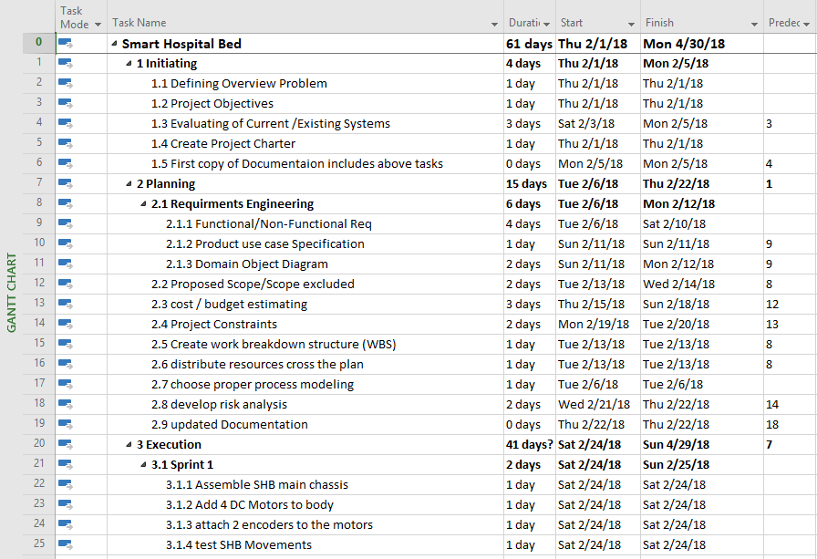

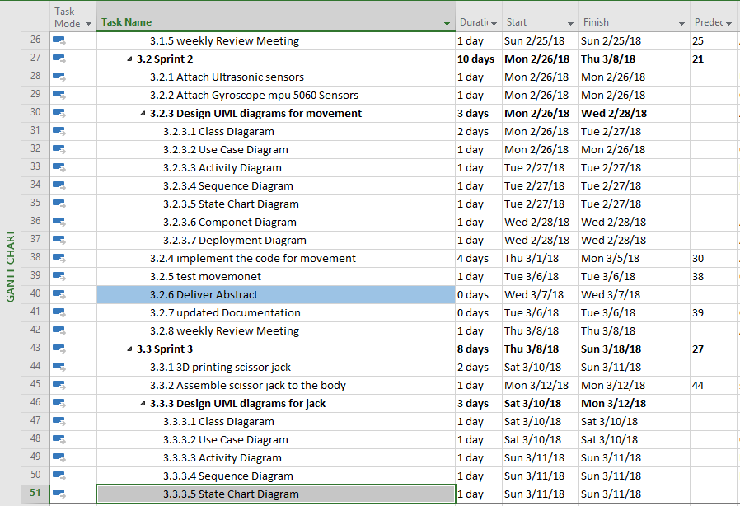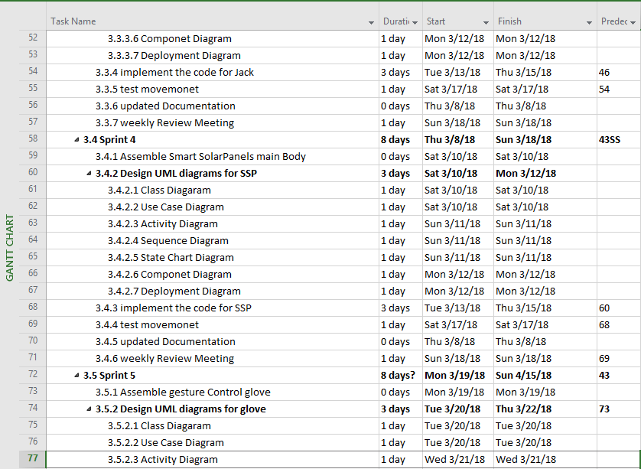

Table 3scope part2

Table 4 Scope part3

Table 5 Scope part 4

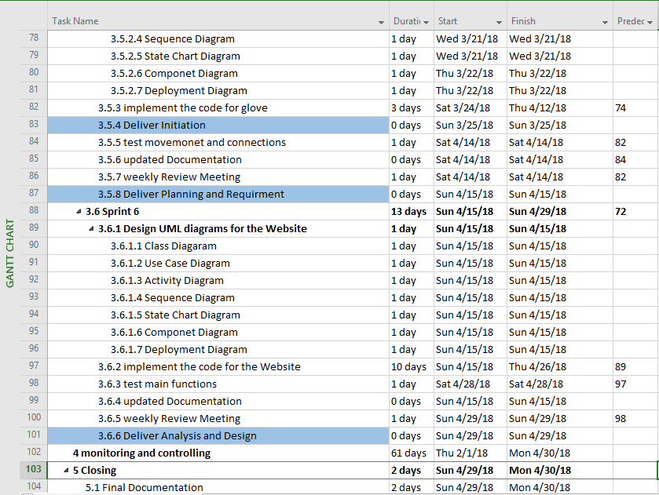

### A screenshot of text Description generated with very high confidence2.1.2 GANTT CHART

Gannt Chart is one way to support time management, activities definition and sequencing.

The following Gantt chart represent the activities in which SHB has been through to be accomplished

Figure 1 gantt chart

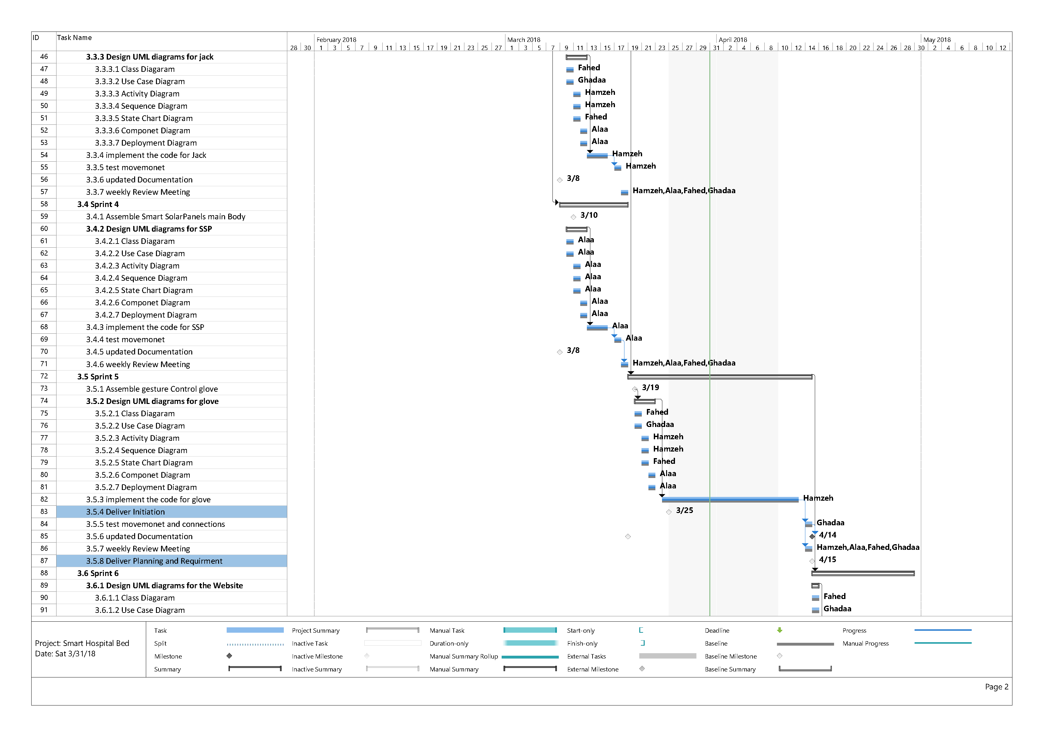

figure 2Gannt chart2

figure 3 gannt chart 3

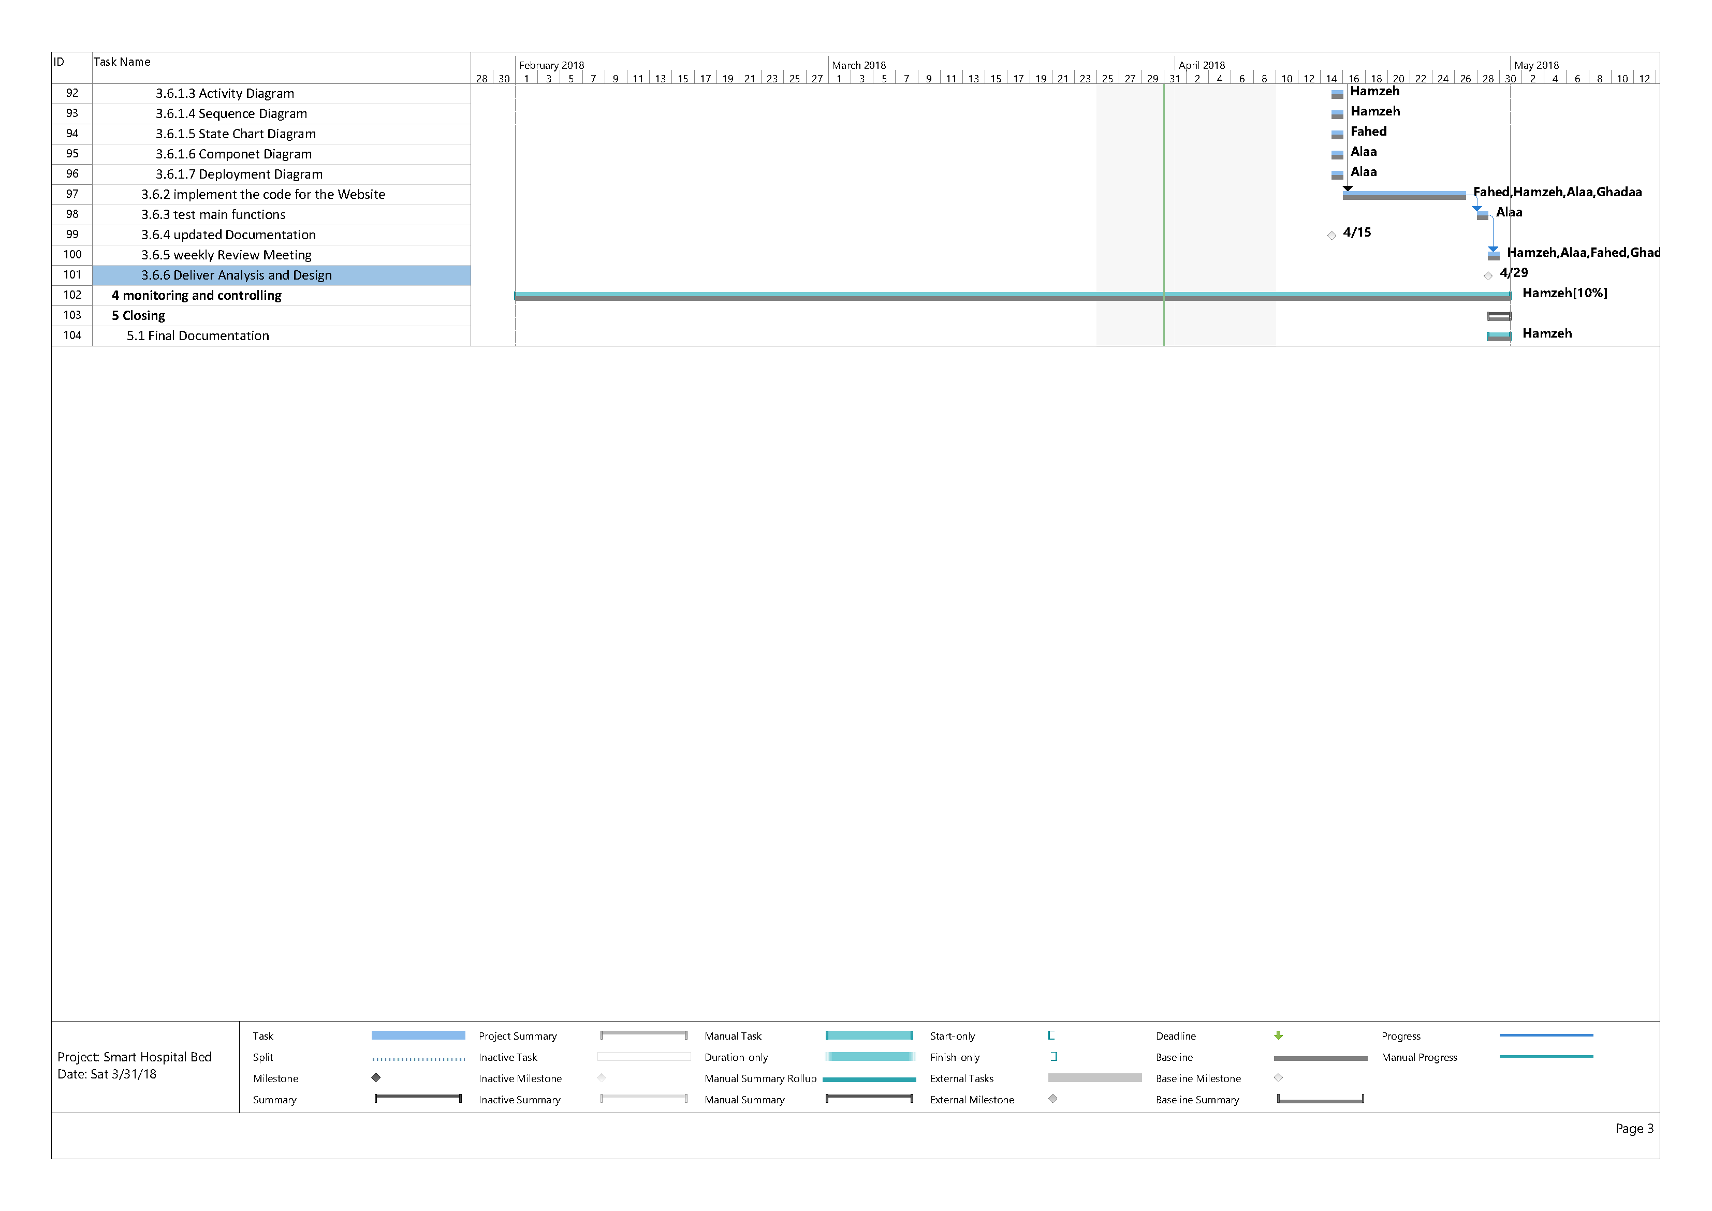

### 2.1.3 RESOURCE PLANNING SCHEDULING AND RESOURCE DISTRIBUTIN

Table 6 Resource Planning part1

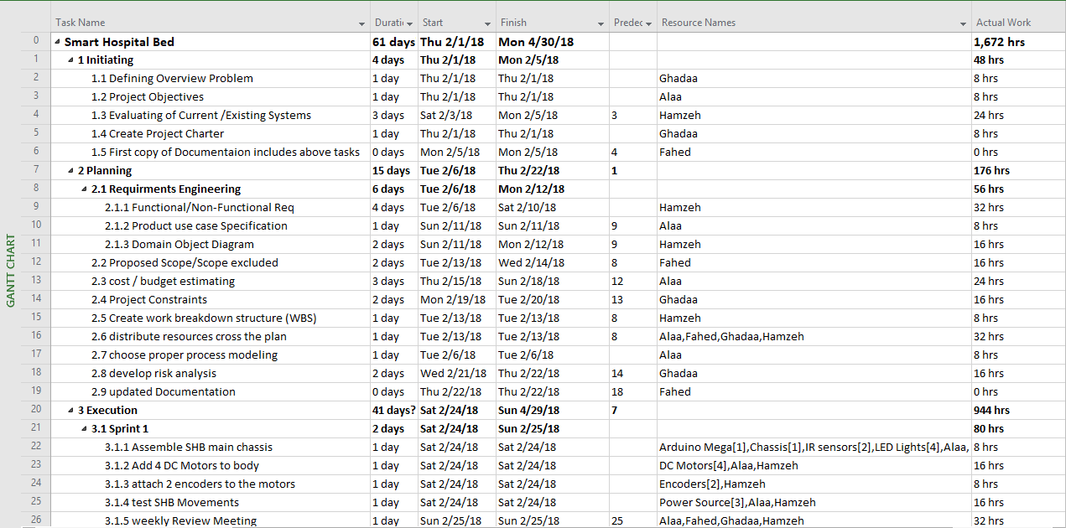

Table 7 Resource planning part2

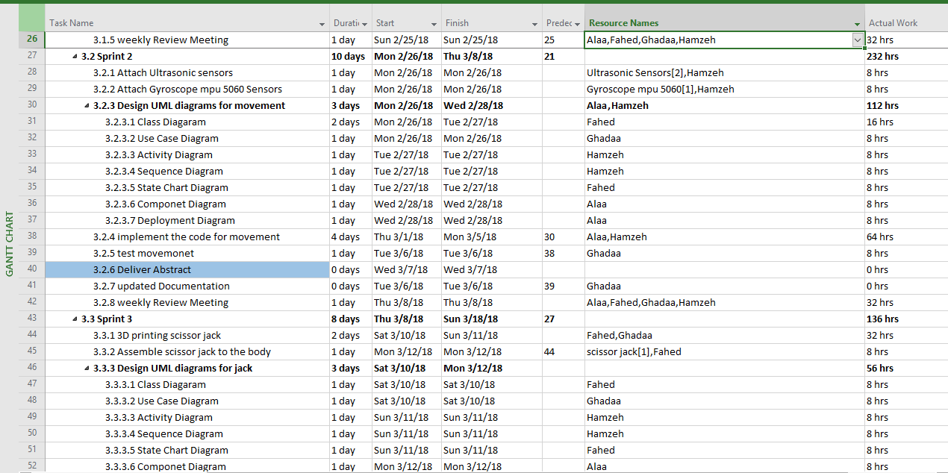

Table 8 Resource planning part3

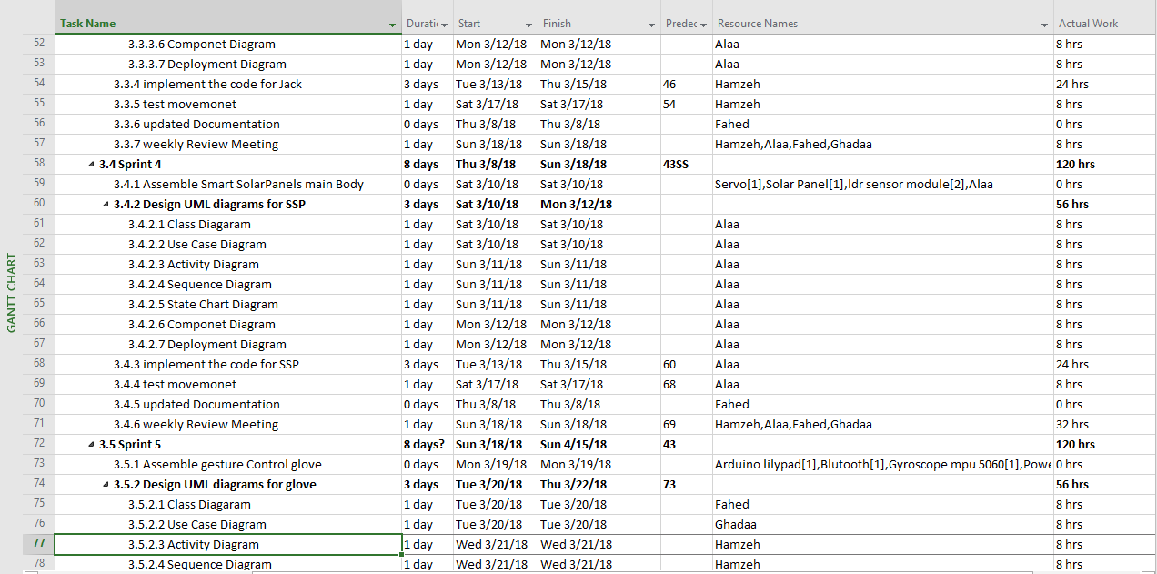

Table 9 Resource planning part4

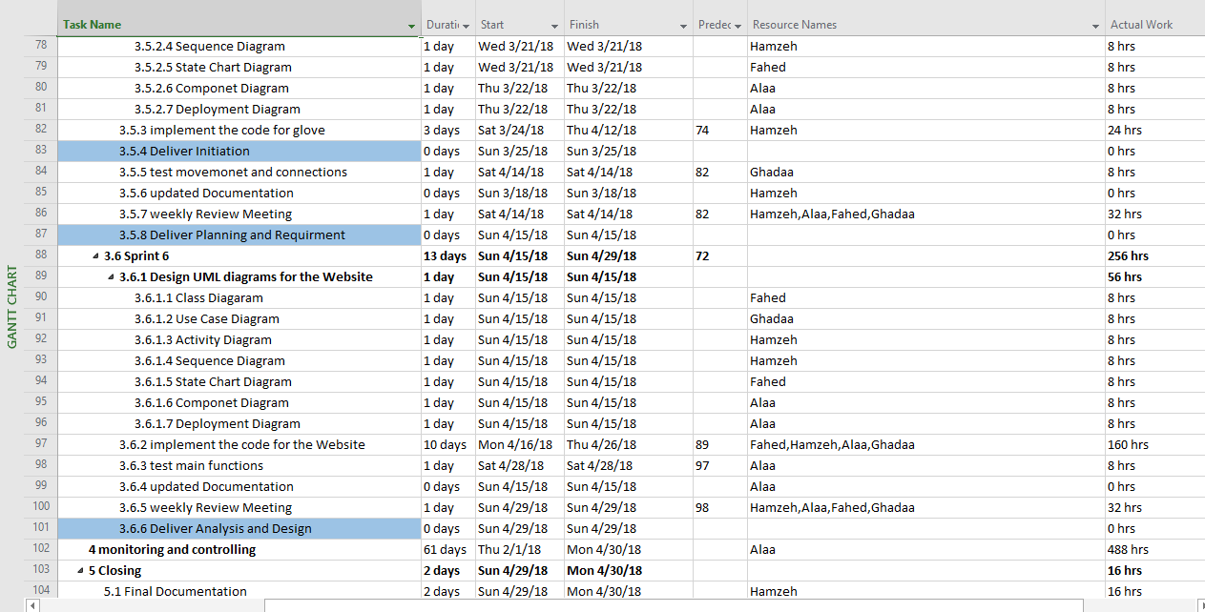

### 2.1.4 SYSTEM DEVELOPMENT REQUIRMENT

|  |  |
| --- | --- |
| Resource Group | Resource Name |
| Software | * Microsoft Project Management pro 365 2016 * Microsoft word 365 2016 * Microsoft Visio pro 365 2016 * Phpstrom 2018.1 * Arduino ide 1.8.5 |
| Hardware | * Chassis [1]. * Dc motors [6]. * Ultrasonic sensor [2]. * Line tracking sensor [2]. * Arduino mega [1]. * Arduino Uno [1]. * Arduino lily [1]. * Gyroscope mpu5060 [2]. * Bluetooth [1]. * Motor shield [1]. * scissor jack [1]. * Power supply [3]. * Solar Panel [1]. * Servo motor [1]. * LDR module [2]. * Encoder [2]. * LED light [8]. |

Table 10 resource Group

### 2.1.5 COST ESTIMATING AND BUDGETING.

By inserting the estimated resources value to the Microsoft project management tools, the following cost has been estimated for SHB Project.

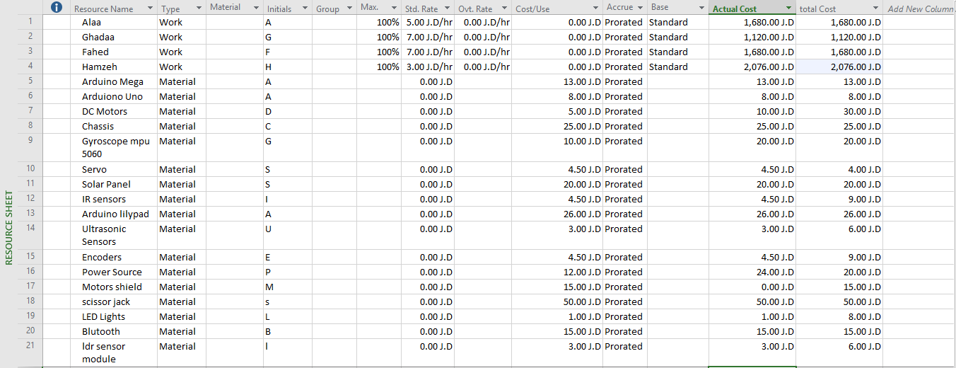

Table 11 Cost estimating and budgeting

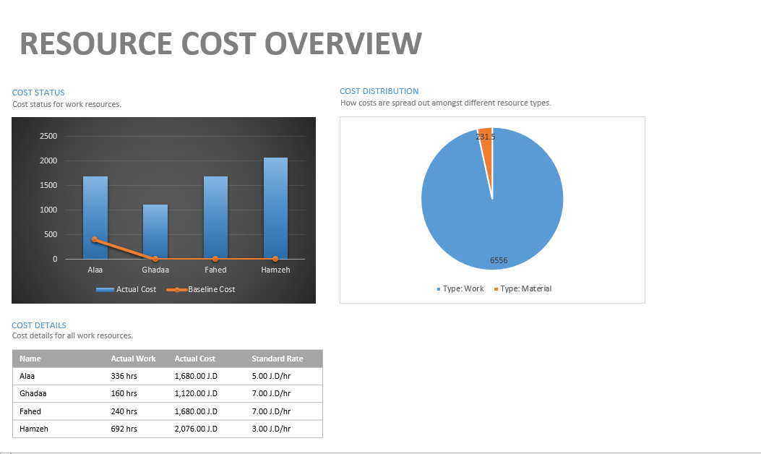

Figure 4 resource cost overview

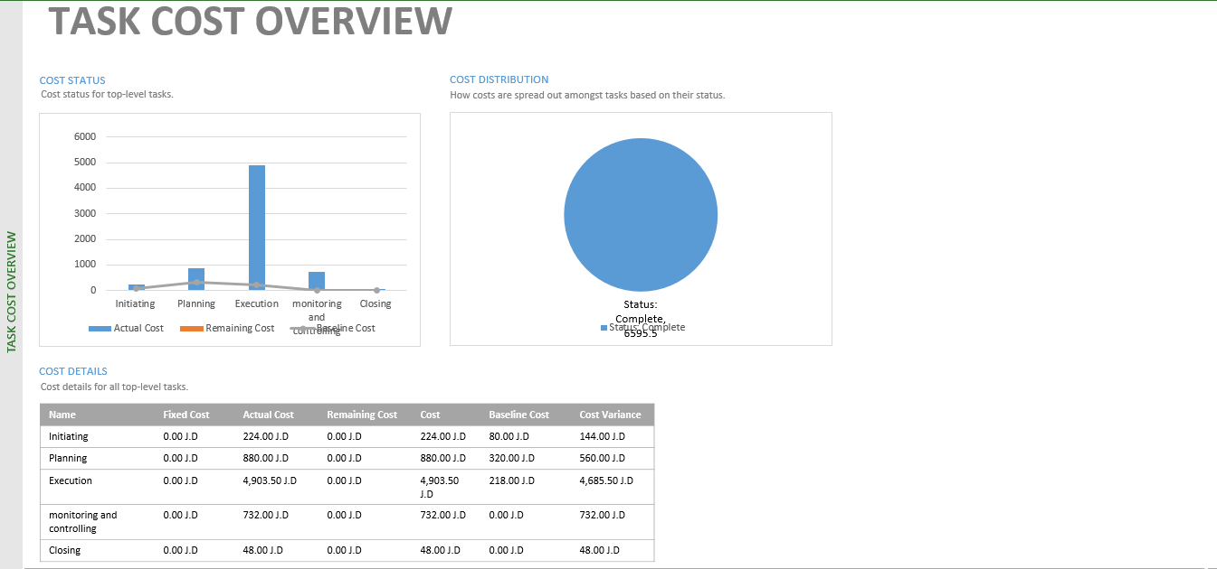

figure 5task cost overview

### 2.1.6 RISK LIST (RISK ANALYSIS).

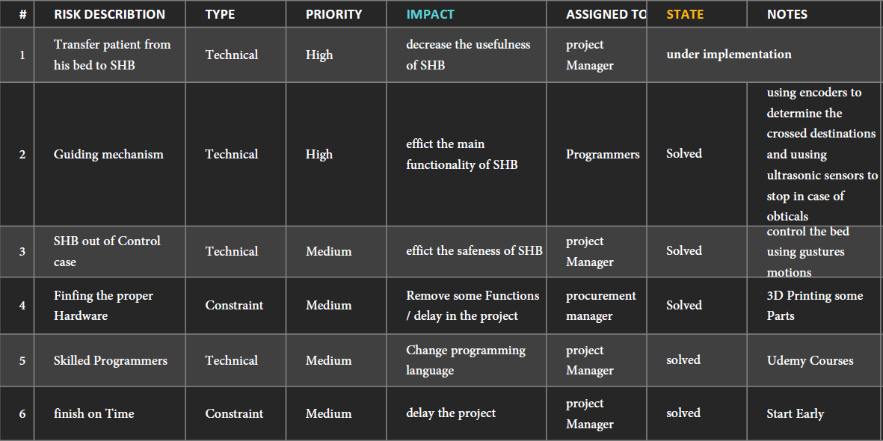

Table 12 risk list

## 2.2 REQUIRMENTS

### 2.2.1 Requirement elicitation techniques

SHB is a Project that is going to be used by Hospitals, Patients and Employees inside the Hospital and that has been taken in consideration and in order to make it convenience for all parts, two elicitation techniques haven been used in order to collect requirements.

1. Observation

The process of transferring the patient from bed to bed and what the nurses go through will dragging the normal hospitals bed has been observe.

1. Questioner

Two forms of questioner have been formed for patient and hospital employee.

### 2.2.2 LIST OF FUNCTIONAL AND NON- FUNCTIONAL REQUIRMENTS

#### 2.2.2.1 FUNCTIONAL REQUIREMENTS.

SBH functional requirements:

1. The system shall allow the user to move SHB one cycle forward.
2. The system shall allow the user to move SHB one cycle backward.
3. The system shall allow the user to move SHB one cycle to the left.
4. The system shall allow the user to move SHB one cycle to the right.
5. The system shall allow the user to steer SHB forward by gesture movement.
6. The system shall allow the user to steer SHB backward by gesture movement.
7. The system shall allow the user to steer SHB left by gesture movement.
8. The system shall allow the user to steer SHB right by gesture movement.
9. The system shall steer autonomy to Operations room by user order.
10. The system shall steer autonomy to patient room by user order.
11. The system shall allow the user to transfer the patient form his bed to SHB.
12. The system shall allow the user to transfer the patient from SHB to his bed.
13. The system shall stop in case of obstacles.

Smart Solar-Panel Functional requirements:

1. The system shall move the panel toward lights.

Website functional requirements:

1. The system shall provide the full Documentation of SHB.
2. The system shall provide tips to troubleshoot problems.
3. The system shall provide support information.
4. The system shall allow the user to enter patient personal information.
5. The system shall allow the user to enter the patient night shift reads.
6. The system shall allow the user to create new user.
7. The system shall allow the user to login.
8. The system shall allow the user to logout.

#### 2.2.2.2 NON-FUNCTIONAL REQUIREMENTS.

SHB non-Functional requirements:

* System Reliability

The reliability that the system will react in the right way according to the sensor reads.

* System Performance  
  The system should response and perform the right action in less than a second.
* System Testability   
  Test environments should be built for the system to allow testing of the system different.

functions.

Smart Solar-Panel non-functional requirements:

Website non-functional requirement:

* website extendibility  
  The website should be easy to extend and add new functions.
* Readability  
  the code should contain enough comments.

### 2.2.3 Use Case Specifications

#### 2.2.3.1 Use Case Specifications for SHB.

1. Use case name: move SHB one cycle forward.

Preconditions: the SHB should be completely stopped.

Interested Stakeholders: nurses.

Flow of Events:

1. The user makes sur that SHB is in idle mood.
2. The user clicks on forward button.
3. The front LED lights turn on.
4. The system moves one cycle forward.

Post Conditions:

SHB stops and the front LED lights are off.

1. Use case name: move SHB one cycle backward.

Preconditions: the SHB should be completely stopped.

Interested Stakeholders: nurses.

Flow of Events:

1. The user makes sur that SHB is in idle mood.
2. The user clicks on backward button.
3. The back-LED lights turn on.
4. The system moves one cycle backward.

Post Conditions:

SHB stops and the back-LED lights are off.

1. Use case name: move SHB one cycle to the left.

Preconditions: the SHB should be completely stopped.

Interested Stakeholders: nurses.

Flow of Events:

1. The user makes sur that SHB is in idle mood.
2. The user clicks on left button.
3. The left-LED lights turn on.
4. The system moves one cycle to the left.

Post Conditions:

SHB stops and the left-LED lights are off.

1. Use case name: move SHB one cycle to the right.

Preconditions: the SHB should be completely stopped.

Interested Stakeholders: nurses.

Flow of Events:

1. The user makes sur that SHB is in idle mood.
2. The user clicks on right button.
3. The right-LED lights turn on.
4. The system moves one cycle to the right.

Post Conditions:

SHB stops and the right-LED lights are off.

1. Use case name: steer SHB forward by gesture movement.

Preconditions: the user wear the controlling glove.

Interested Stakeholders: nurses.

Flow of Events:

1. The user activates control glove by turning on the switch on the glove.
2. The system stops the autonomous control.
3. The system activates the gesture control mode.
4. The user leans his hand downward.
5. SHB start moving forward.

Post Conditions:

SHB stops and the front-LED lights are off.

1. Use case name: steer SHB backward by gesture movement.

Preconditions: the user wear the controlling glove.

Interested Stakeholders: nurses.

Flow of Events:

1. The user activates control glove by turning on the switch on the glove.
2. The system stops the autonomous control.
3. The system activates the gesture control mode.
4. The user leans his hand upward.
5. SHB start moving backward.

Post Conditions:

SHB stops and the back-LED lights are off.

1. Use case name: steer SHB to the left by gesture movement.

Preconditions: the user wear the controlling glove.

Interested Stakeholders: nurses.

Flow of Events:

1. The user activates control glove by turning on the switch on the glove.
2. The system stops the autonomous control.
3. The system activates the gesture control mode.
4. The user leans his hand to the left.
5. SHB start moving to the left.

Post Conditions:

SHB stops and the left-LED lights are off.

1. Use case name: steer SHB to the right by gesture movement.

Preconditions: the user wear the controlling glove.

Interested Stakeholders: nurses.

Flow of Events:

1. The user activates control glove by turning on the switch on the glove.
2. The system stops the autonomous control.
3. The system activates the gesture control mode.
4. The user leans his hand to the right.
5. SHB start moving to the right.

Post Conditions:

SHB stops and the right-LED lights are off.

1. Use case name: steer autonomy to Operations room by user order.

Preconditions: the user makes sure that the SHB will start next to the patient bed.

Interested Stakeholders: nurses.

Flow of Events:

1. The user press on operation room button.
2. The system start moving according to sensors reads.
3. The system reaches operation room.
4. System stops.
5. LED lights are off.

Post Conditions:

SHB stops and the LED lights are off.

1. Use case name: steer autonomy to patient room by user order.

Preconditions: SHB is in operation room.

Interested Stakeholders: nurses / Doctors.

Flow of Events:

1. The user press on patient room button.
2. The system starts moving according to sensors reads.
3. The system reaches patients room.
4. System stops.
5. LED lights are off.

Post Conditions:

SHB stops and the LED lights are off.

1. Use case name: allow the user to transfer the patient form his bed to SHB.

Preconditions: SHB is in idle mode and side by side to the patient’s bed.

Interested Stakeholders: nurses / Doctors.

Flow of Events:

1. The user makes sure that the SHB in the right position where the slider is perfectly fit under the mattress.
2. The user press on the slider button.
3. The system starts to move the slider under the mattress.
4. The user locks the safety lock.
5. The user presses the slider button again.
6. The system starts to drag the mattress toward the SHB.

Post Conditions:

The patient mattress is over the SHB.

1. Use case name: allow the user to transfer the patient from SHB to his bed.

Preconditions: SHB is in idle mode and side by side to the patient’s bed.

Interested Stakeholders: nurses / Doctors.

Flow of Events:

1. The user makes sure that the SHB in the right position where the slider is perfectly fit next to the patient bed.
2. The user press on the slider button.
3. The system starts to move the slider over the patient’s bed.
4. The user unlocks the safety lock.
5. The user presses the slider button again.
6. The system releases the mattress over the patient bed.

Post Conditions:

The patient mattress is over the patient bed.

1. Use case name: stop in case of obstacles.

Preconditions: SHB is in movement.

Interested Stakeholders: nurses / Doctors/patient / crossers.

Flow of Events:

1. The ultrasonic sensors detect a nearby obstacle.
2. The sensors send the reads to the mega board.
3. The mega board send an order to stop all DC motors.

Post Conditions:

The SHB starts to move again.

1. Use case name: shall adjust its movement in case of safety line detection.

Preconditions: SHB is in movement.

Interested Stakeholders: nurses / Doctors/patient / crossers.

Flow of Events:

1. The IR sensors detect the safety line.
2. The sensors send the reads to the mega board.
3. The mega board send an order adjust the movement.

Post Conditions:

The SHB starts to move forward again.

#### 2.2.3.2 Use Case Specifications for website

1. Use case name: provide full Documentation of SHB.

Preconditions: open SHB website.

Interested Stakeholders: anyone interested in the bed.

Flow of Events:

1. The user opens the website
2. The user clicks on documentation from navbar
3. The system displays a page with full documentation of the SHB project.

Post Conditions:

.

1. Use case name: provide tips to troubleshoot problems

Preconditions: open SHB website.

Interested Stakeholders: anyone interested in the bed.

Flow of Events:

1. The user opens the website
2. The user clicks on documentation from navbar
3. The system displays a page with full documentation of the SHB project.
4. The user clicks on troubleshoot button at the bottom of the page.
5. The system displays Q&A page.
6. Use case name: provide support information

Preconditions: open SHB website.

Interested Stakeholders: anyone interested in the bed.

Flow of Events:

1. The user opens the website
2. The user clicks on developers button from navbar
3. The system display developers and their contact information to contact with.

post condition

…

1. Use case name: allow the user to enter patient personal information.

Preconditions: login using nurse account.

Interested Stakeholders: nurse.

Flow of Events:

1. The user login in using nurse account.
2. The user chooses patient list.
3. The system displays list of patient’s names.
4. The user chooses patient from the list
5. The user chooses to edit personal information
6. The user enters the personal information
7. The user clicks on save
8. The system saves the data in the database

post condition

confirmation message.

1. Use case name: allow the user to enter the patient night shift reads.

Preconditions: login using nurse account.

Interested Stakeholders: nurse.

Flow of Events:

1. The user login in using nurse account.
2. The user chooses patient list.
3. The system displays list of patient’s names.
4. The user chooses patient from the list
5. The user chooses to add night shift reads
6. The user enters the night-shift reads
7. The user clicks on save
8. The system saves the data in the database

post condition

confirmation message.

1. Use case name: allow the user to enter the patient night shift reads.

Preconditions: login using nurse account.

Interested Stakeholders: nurse.

Flow of Events:

1. The user login in using nurse account.
2. The user chooses patient list.
3. The system displays list of patient’s names.
4. The user chooses patient from the list
5. The user chooses to add night shift reads
6. The user enters the night-shift reads
7. The user clicks on save
8. The system saves the data in the database

post condition

confirmation message.

1. Use case name: allow the user to create new user.

Preconditions:

Interested Stakeholders: nurse.

Flow of Events:

1. The user fills his/her name, Email, Password, Gender up.
2. The user clicks on submit.
3. The system checks the validate of the information.
4. The system displays confirmation massage.

post condition

confirmation message.

1. Use case name: allow the user to login.

Preconditions: has a username and password.

Interested Stakeholders: nurse.

Flow of Events:

1. The user fills his/her Email and Password up.
2. The user clicks on login.
3. The system checks the validate of the information.
4. The system displays user’s profile page.

post condition

The system displays user’s profile page.

1. Use case name: allow the user to logout.

Preconditions: already logged in.

Interested Stakeholders: nurse.

Flow of Events:

1. The user clicks on logout.
2. The system logout the user’s profile page.
3. The system displays main page.

post condition

The system displays main page.

### 2.2.4 Domain Object Diagram

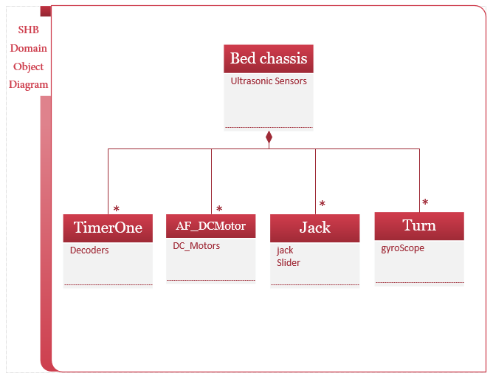

Figure 6 Domain Object Diagram SHB

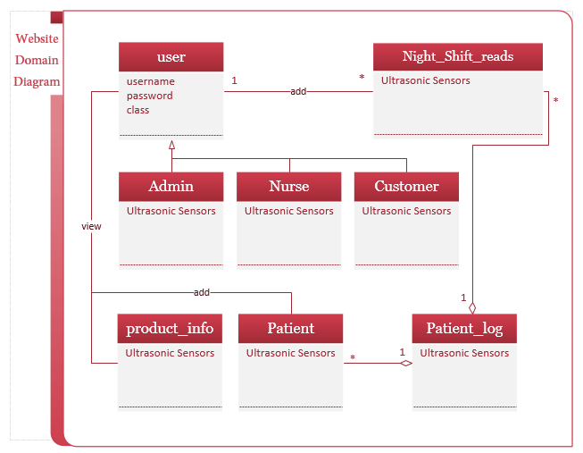

figure 7 Domain Object Diagram website

## 2.3 Result

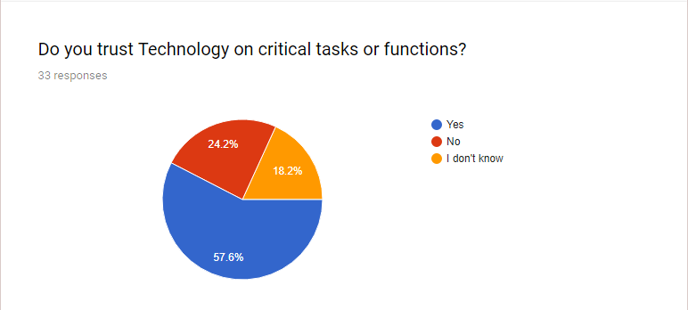

figure 8 result 1

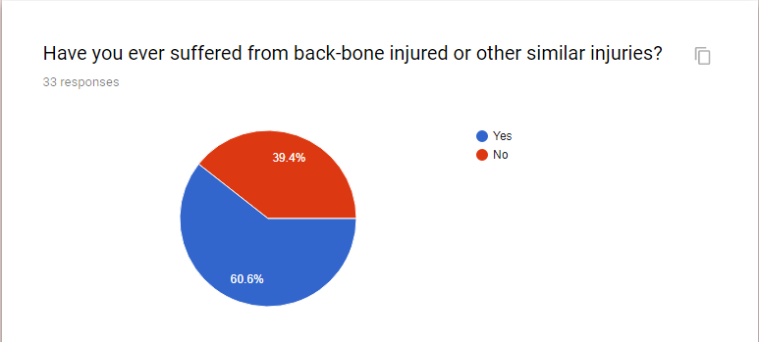

figure 9 Result 2

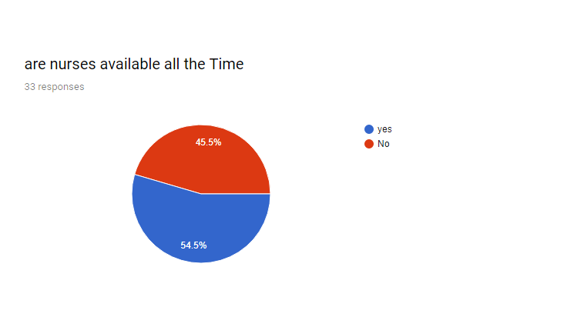

figure 10 result 3

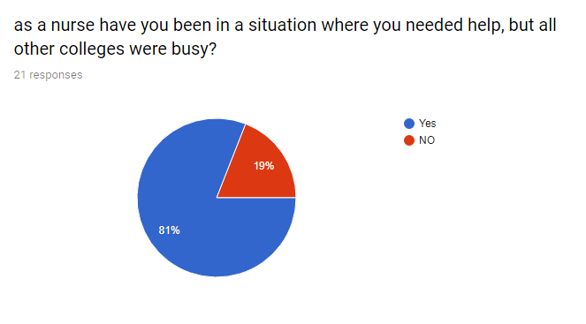

figure 11result 4

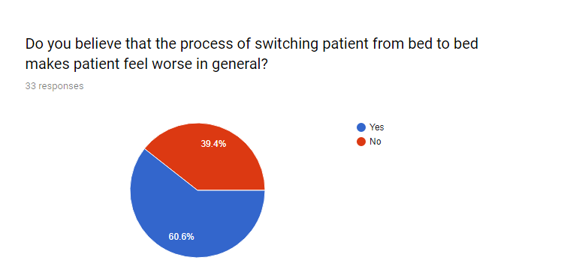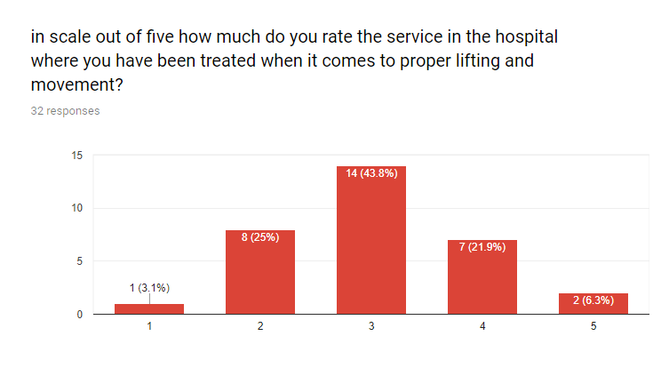

figure 12result 6

figure 13 result 5

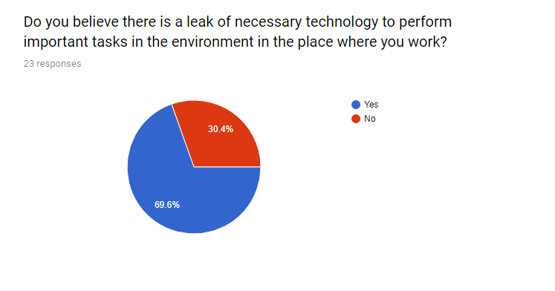Nurse Answers of Questionnaire

figure 14 result 7

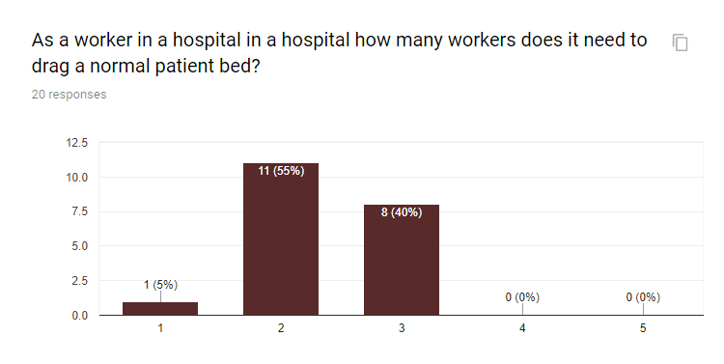

figure 15result 8

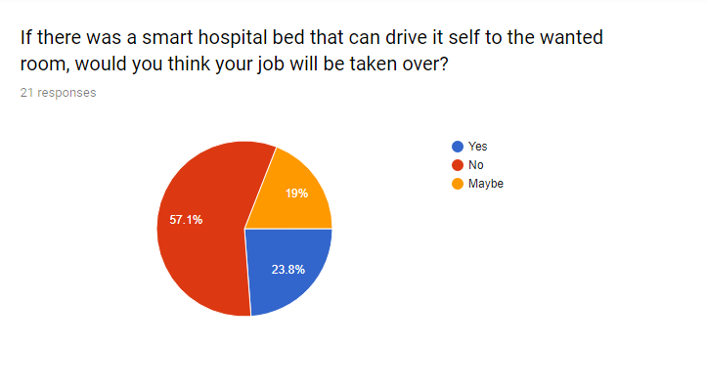

figure 16 result 9

CHAPTER 3

# 3.Planning and Requirements

## 3.1 use case diagram

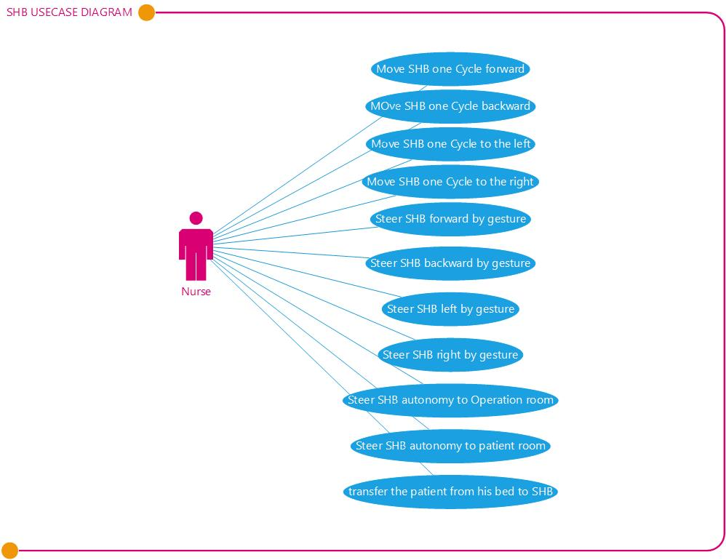

figure 17SHB usecase diagram

use case diagram at its simplest is a representation of a user's interaction with the system that shows the relationship between the user and the different use cases in which the user is involved. A use case diagram can identify the different types of users of a system and the different use cases and will often be accompanied by other types of diagrams as well.

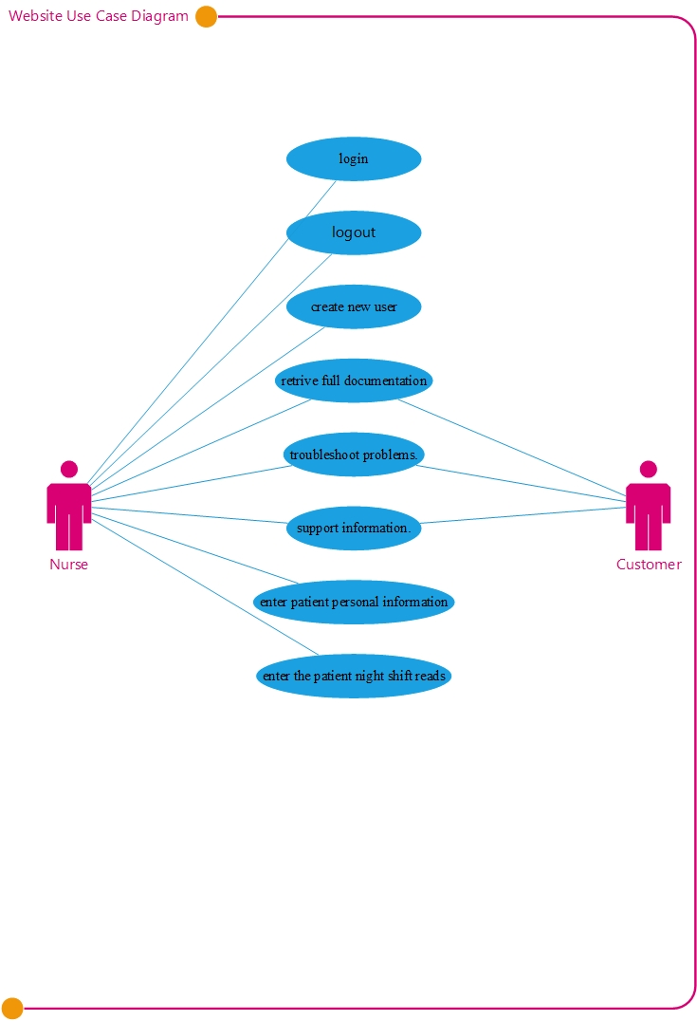

figure 18website use case diagram

## 3.2 Activity Diagram

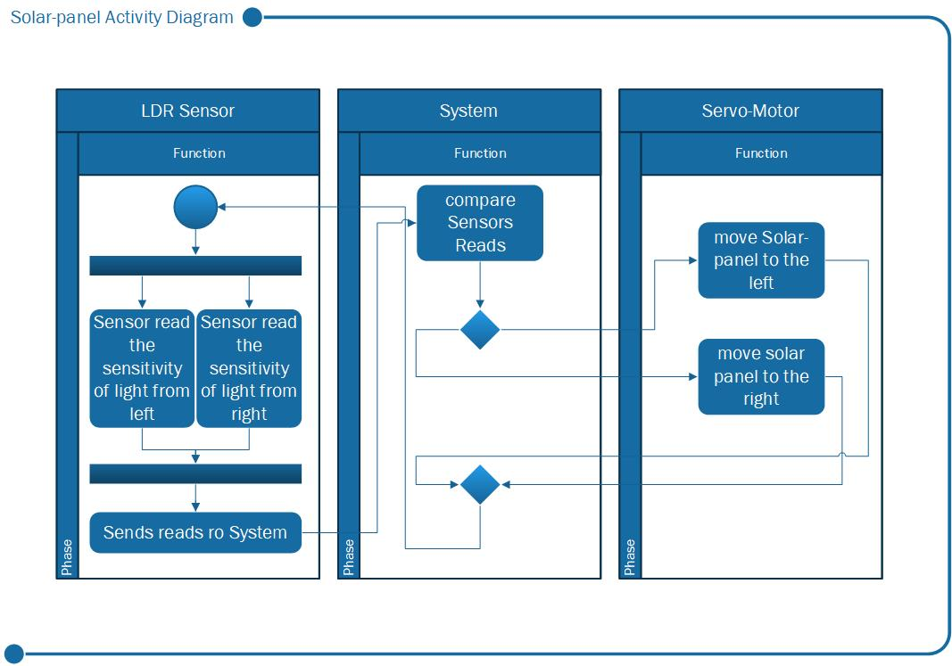

figure 19 Solar panel activity Diagram

Activity diagram is another important diagram in UML to describe the dynamic aspects of the system.

Activity diagram is basically a flowchart to represent the flow from one activity to another activity. The activity can be described as an operation of the system.

Gesture Control Activity Diagram

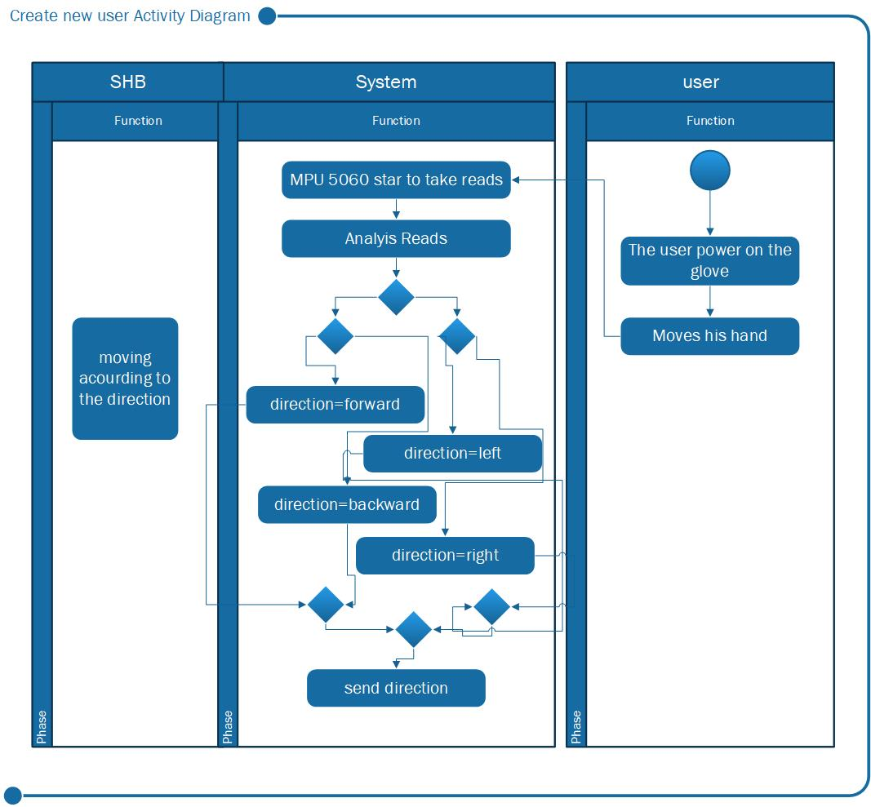

figure 20 Gesture control Activity Diagram

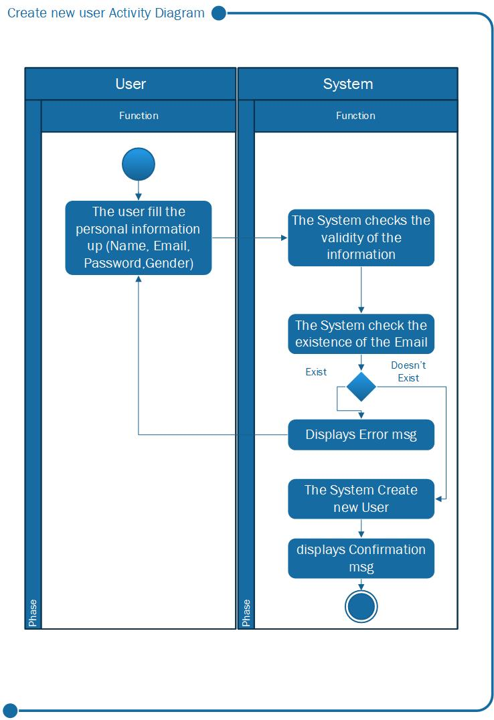

figure 21create new user

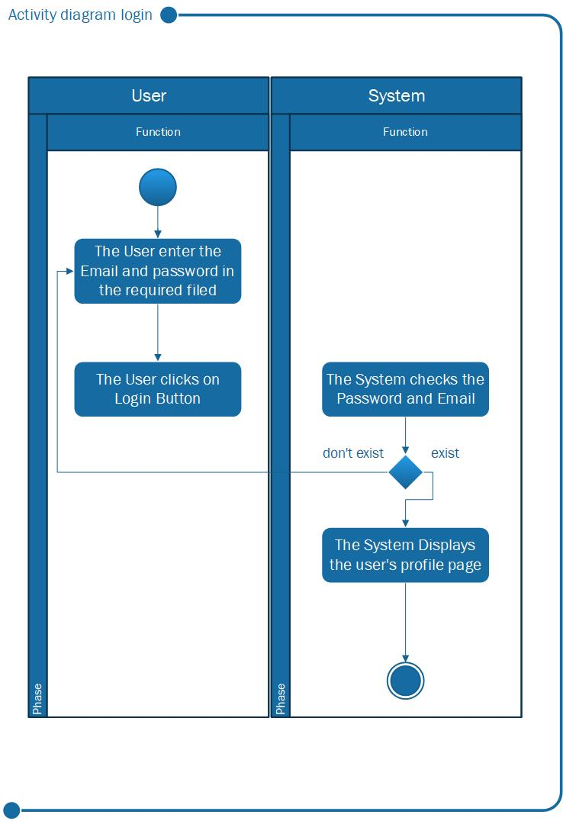

figure 22 login Activity Diagram

## 3.3 Sequence Diagram

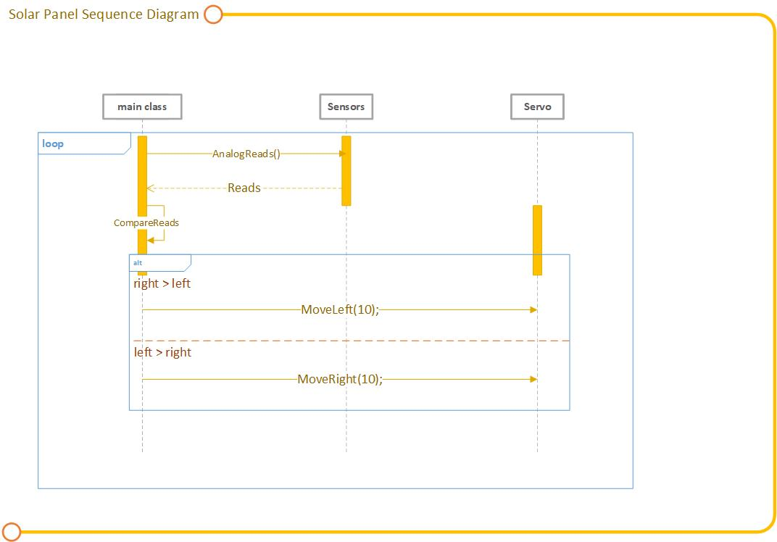

figure 23Solar panel Sequence Diagram

sequence diagram shows object interactions arranged in time sequence. It depicts the objects and classes involved in the scenario and the sequence of messages exchanged between the objects needed to carry out the functionality of the scenario. The diagram above shows the sequence of procurers for the solar panel movement.

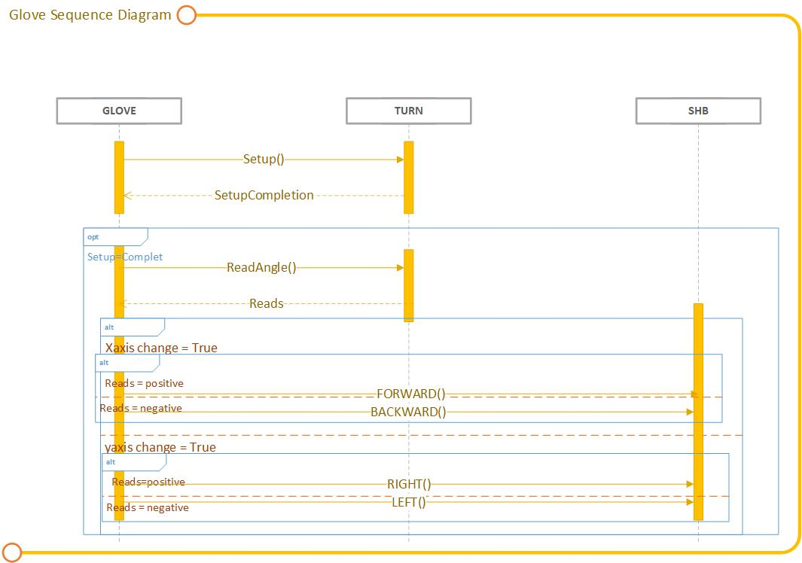

figure 24 Glove Sequence Diagram

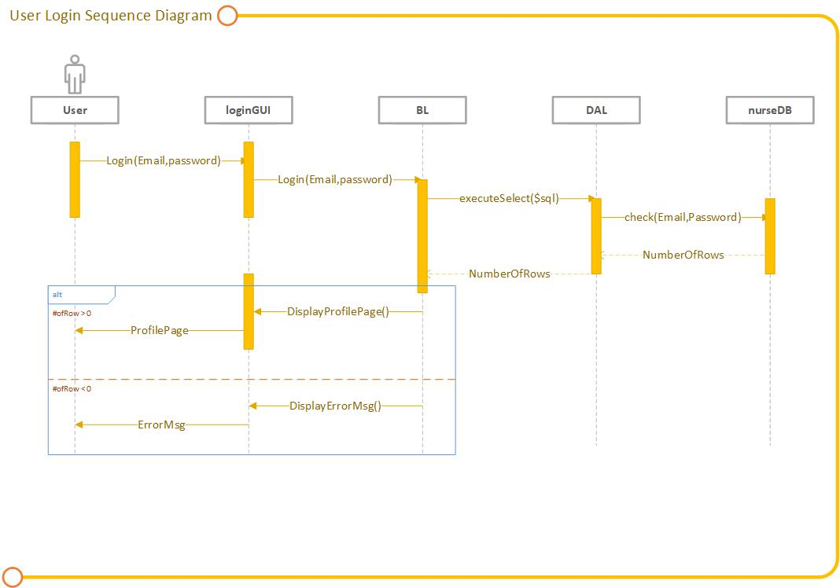

figure 25 user login sequence diagram

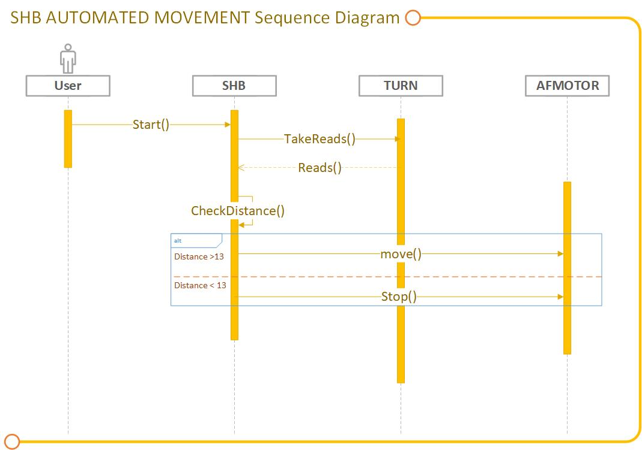

figure 26 shb automated movement sequence diagram

## 3.4 State Diagram

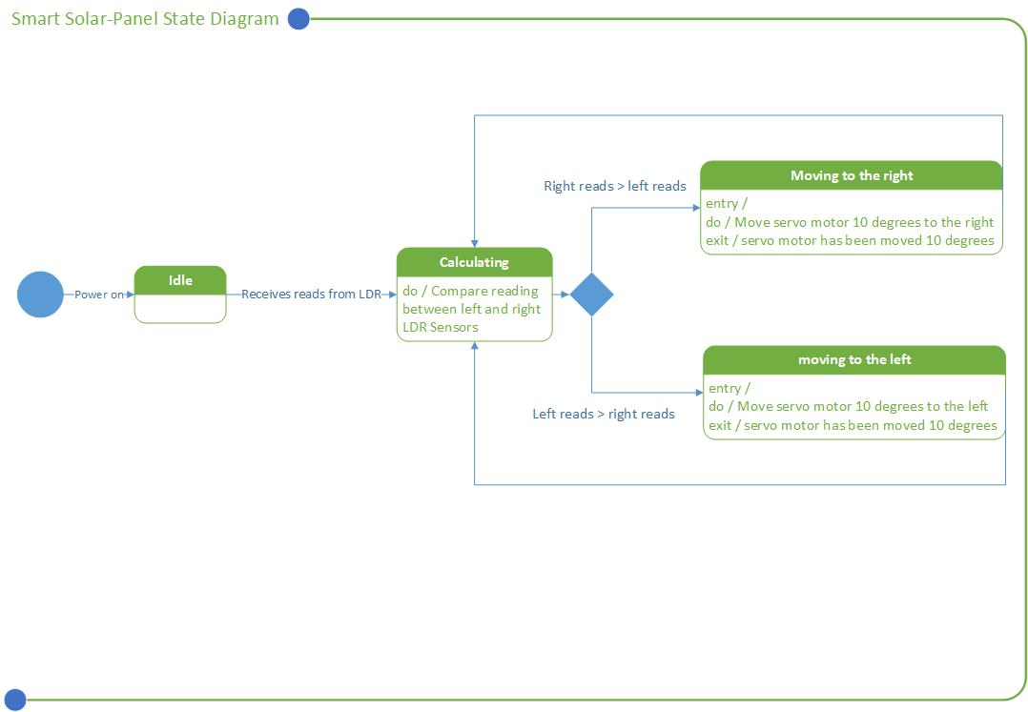

figure 27 smart solar panel state diagram

A state diagram is a type of diagram used in computer science and related fields to describe the behavior of systems. State diagrams require that the system described is composed of a finite number of states; sometimes, this is indeed the case, while at other times this is a reasonable abstraction. Many forms of state diagrams exist, which differ slightly and have different semantics.

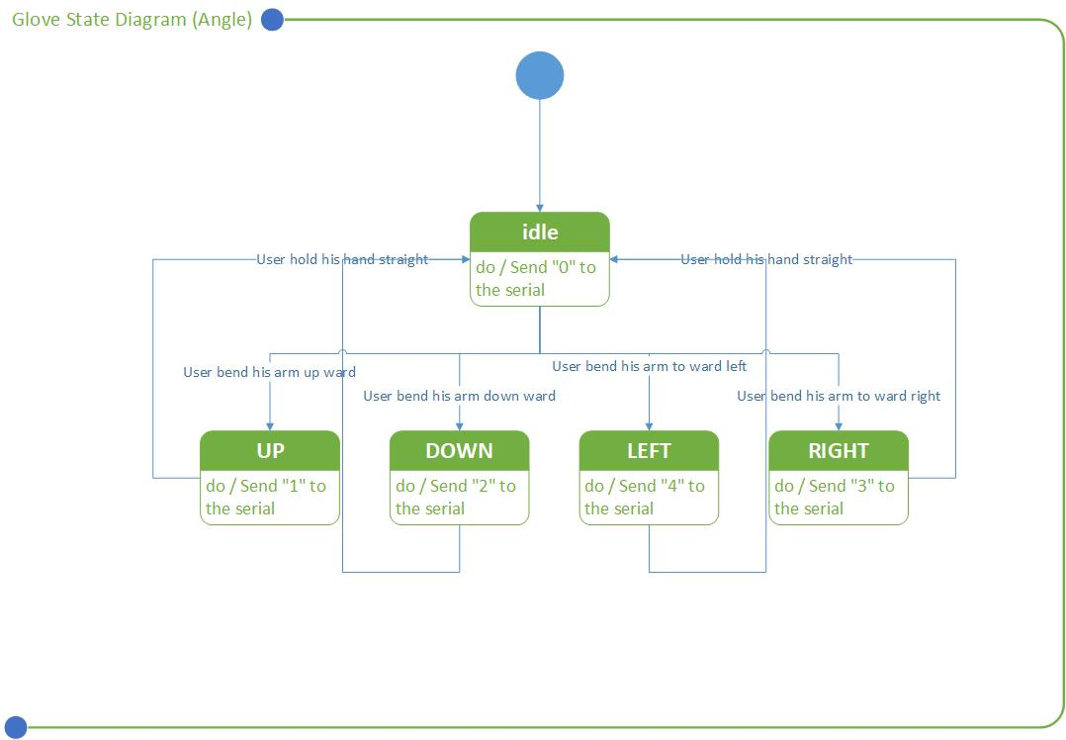

figure 28glove state diagram

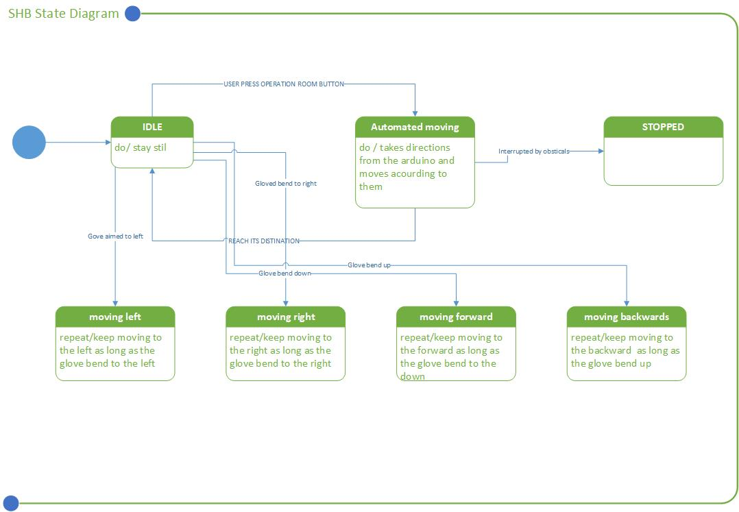

figure 29 shb state diagram

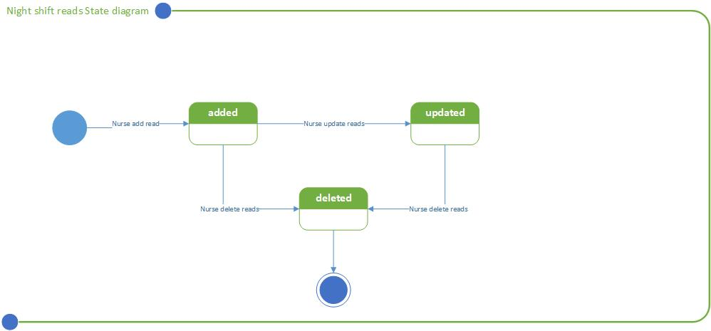

figure 30 night reads state diagram

## 3.5 Class diagram

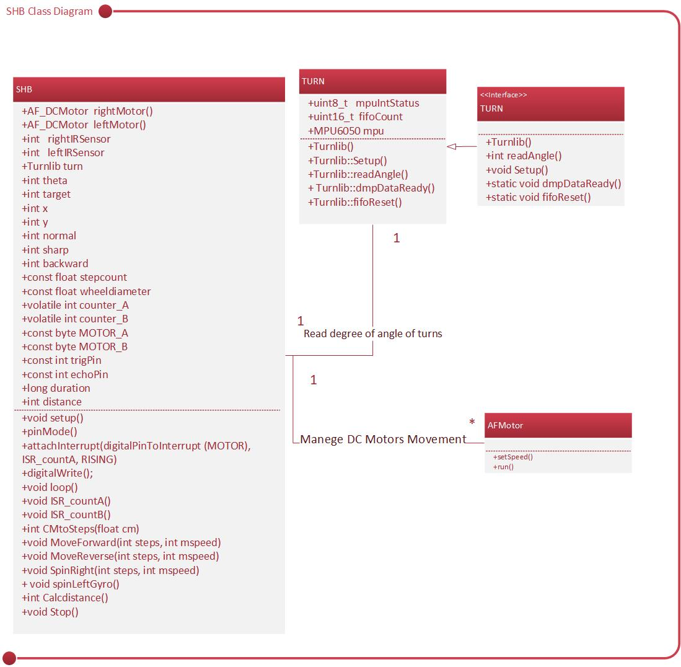

figure 31shb class diagram

In software engineering, a class diagram in the Unified Modeling Language (UML) is a type of static structure diagram that describes the structure of a system by showing the system's classes, their attributes, operations (or methods), and the relationships among objects.

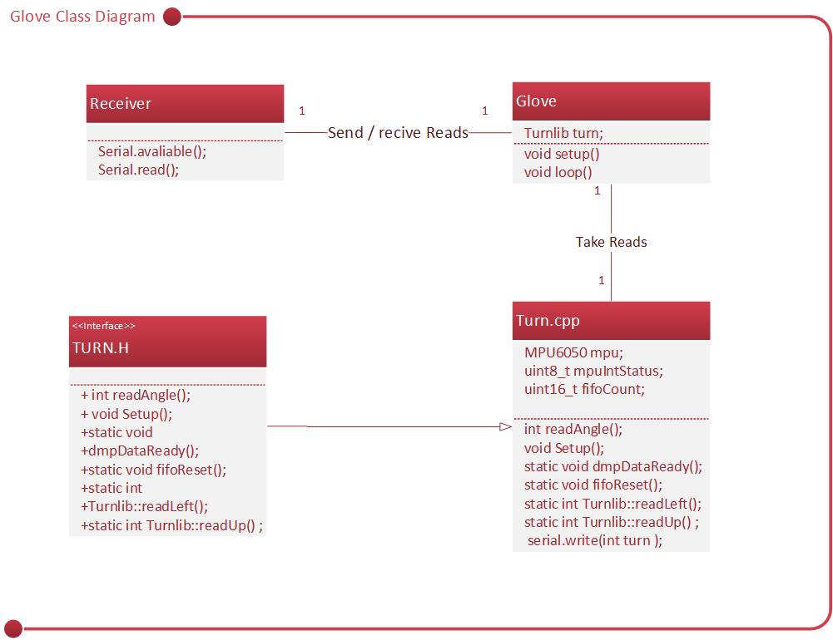

figure 32 glove class diagram

## 3.6 Component Diagram

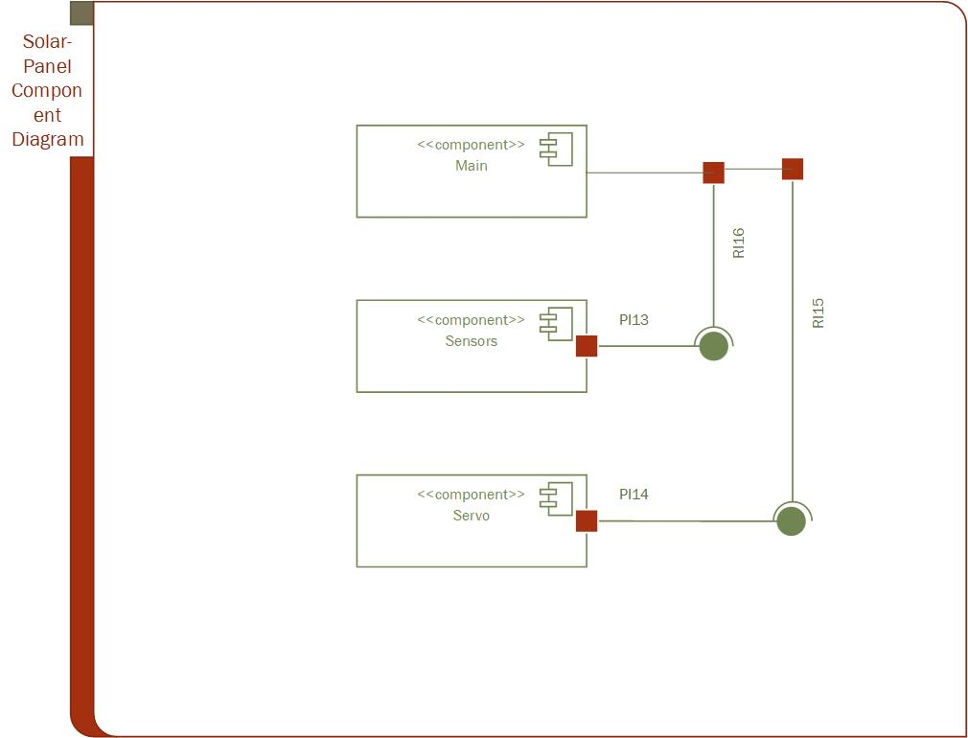

figure 33 solar panel component diagram

Component diagrams are different in terms of nature and behavior. Component diagrams are used to model the physical aspects of a system. Now the question is, what are these physical aspects? Physical aspects are the elements such as executables, libraries, files, documents, etc. which reside in a node.

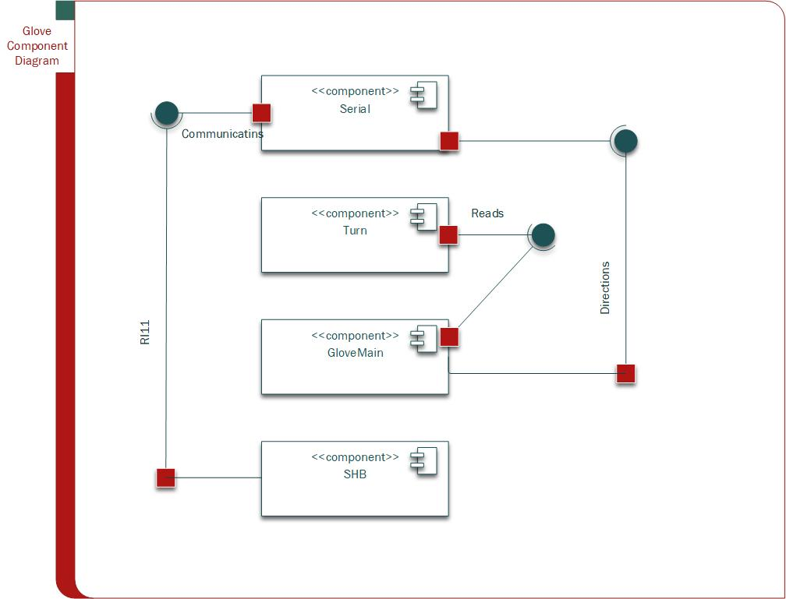

figure 34 glove component diagram

## 3.7 Deployment Diagram

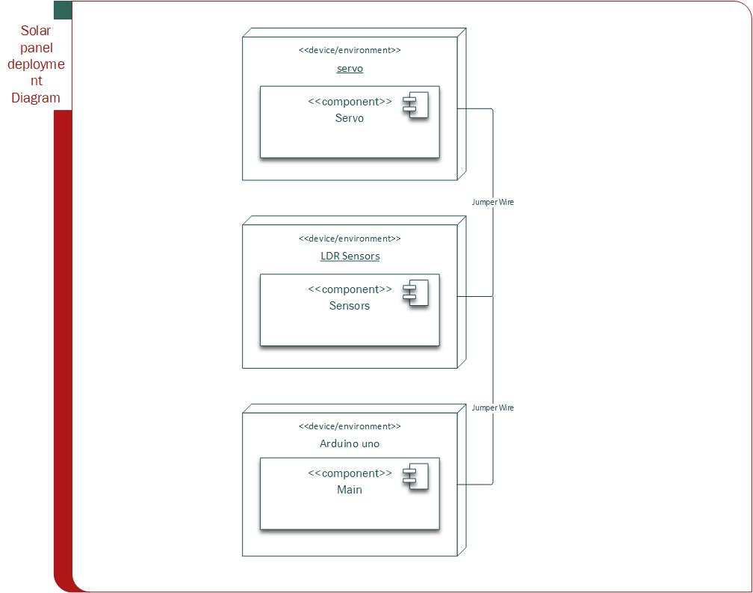

figure 35 Solar Deployment Diagram

Deployment diagrams are made up of several UML shapes. The three-dimensional boxes, known as nodes, represent the basic software or hardware elements, or nodes, in the system. Lines from node to node indicate relationships, and the smaller shapes contained within the boxes represent the software artifacts that are deployed.

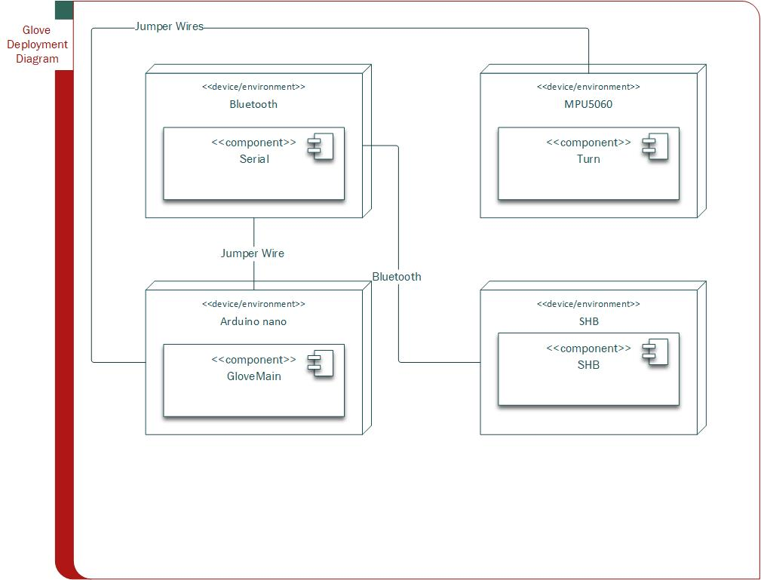

## 3.8 Output Layer

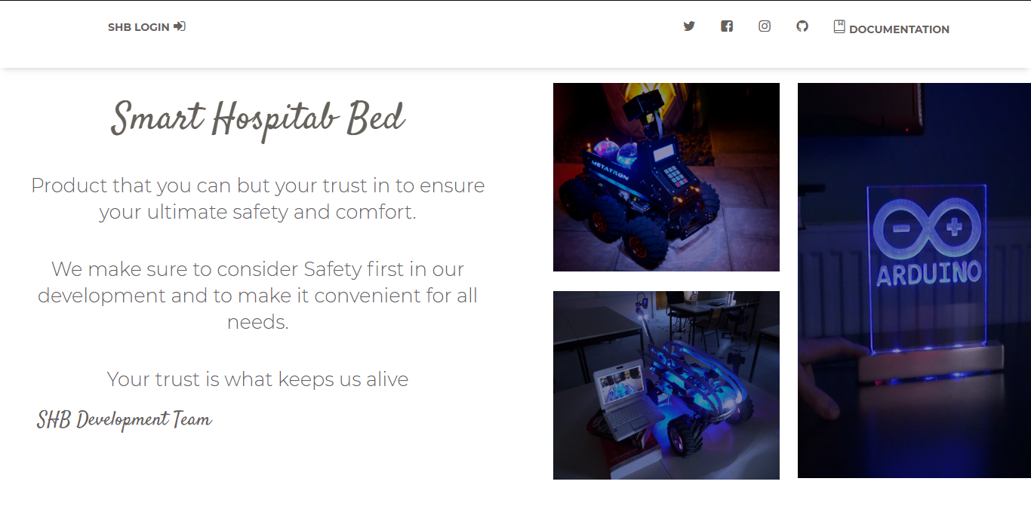





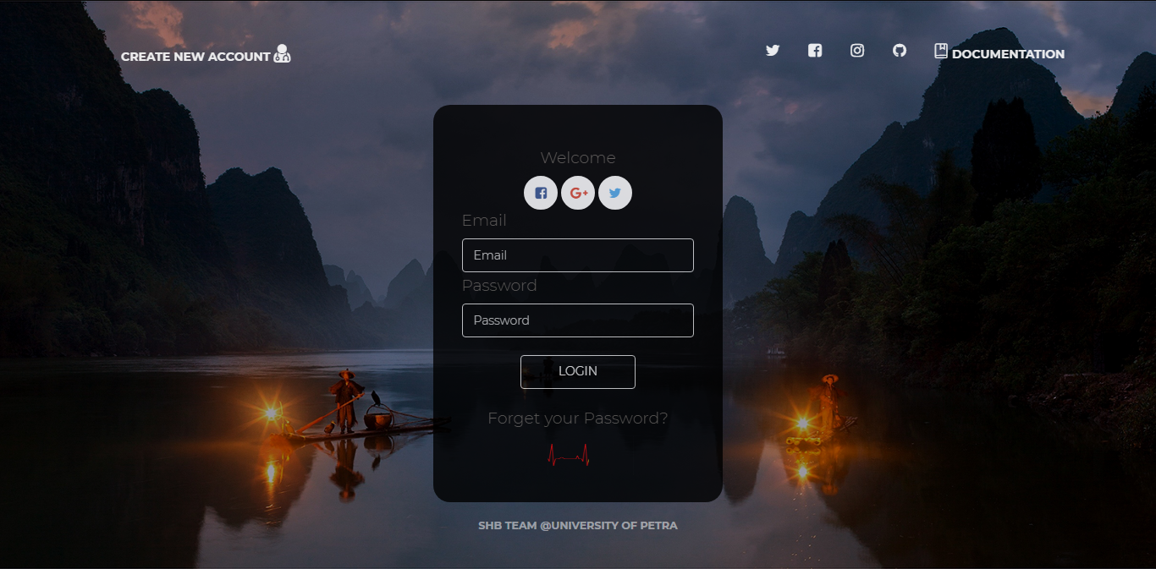

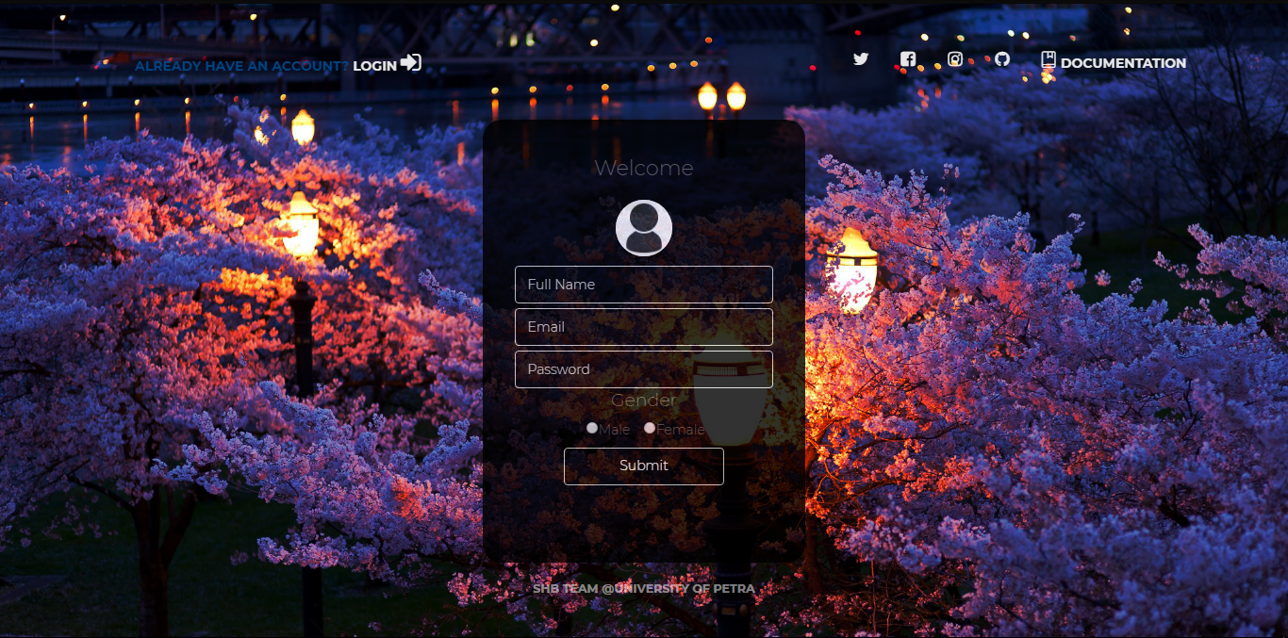

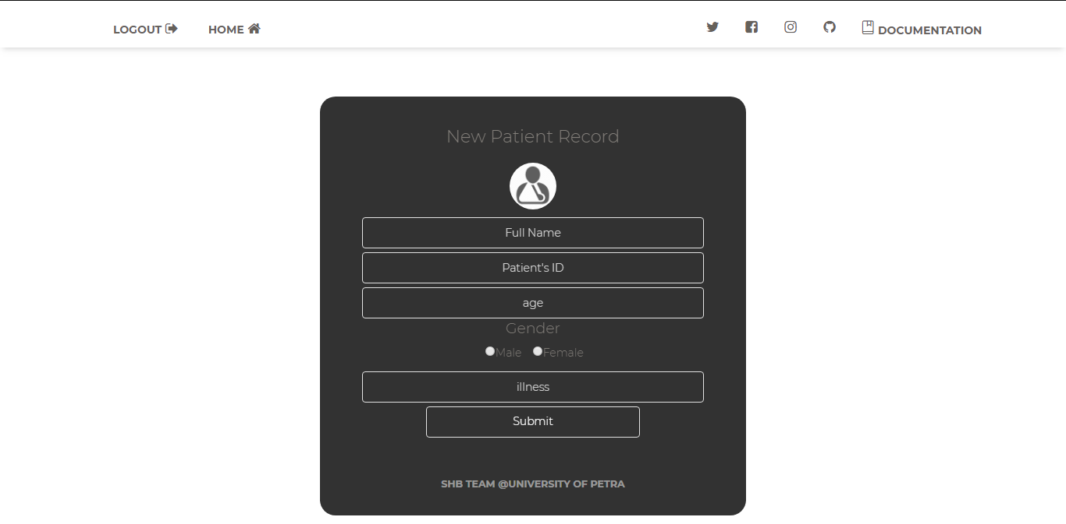

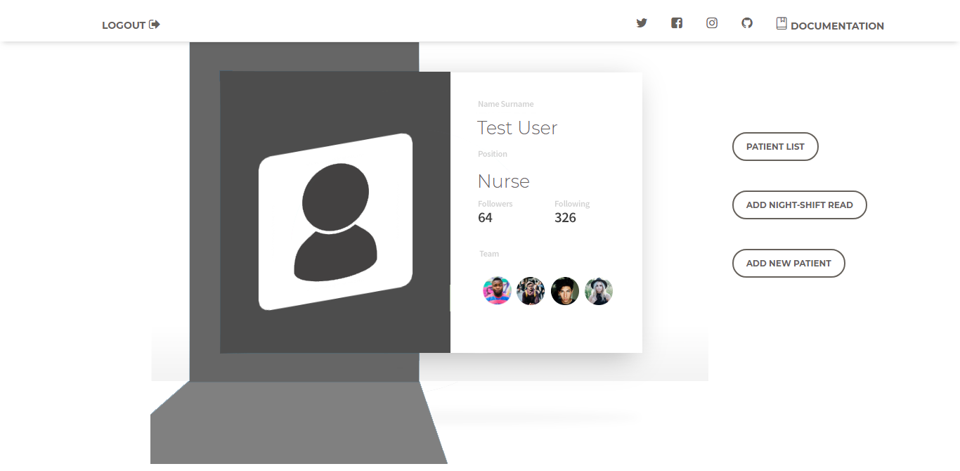

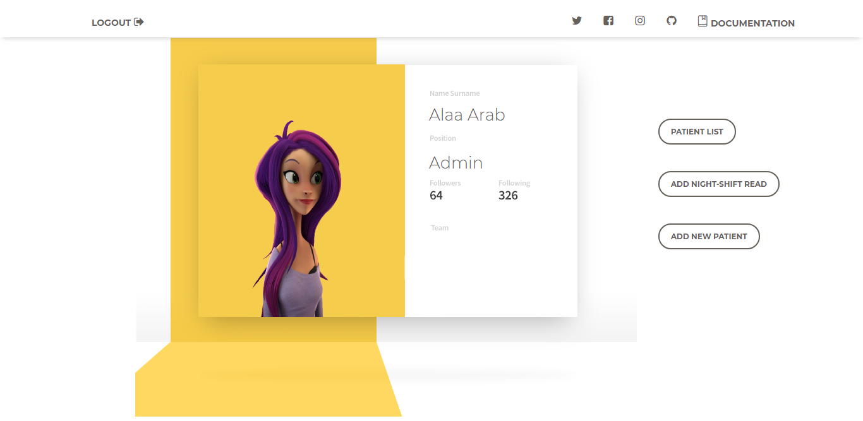

CHAPTER 4

# 4.IMPLEMENTATION AND TESTING

## 4.1 website database mapping

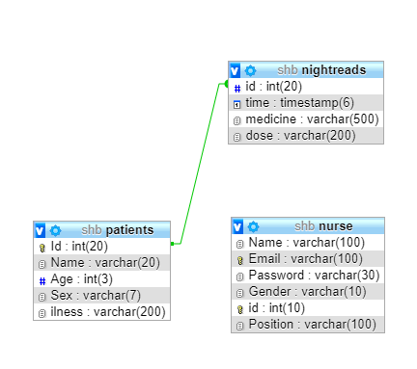

figure 26 website database mapping

## Table description

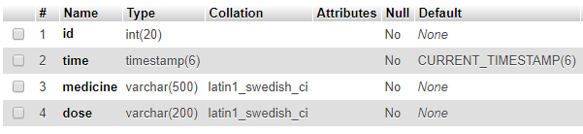

figure 27 nightreads table

the table figure above shows the description of “nightreads” table where the “id” column contains the id of the patient whose information will be taken, “Time” tells the time whenever the night reads has been taken and its fill automatically, “medicine” where the given medicine is stored and “dose” the dosage of it.

## 4.3 Architecture/technology Description

We followed the object-oriented architecture where it goes side to side with the 3 Tier architecture.

The main graphical user interface calls methods in classes, each method in those classes call a method in business logic class where it sends an SQL command to data connection class.

Layered architecture focuses on the grouping of related functionality within an application into distinct layers that are stacked vertically on top of each other. Functionality within each layer is related by a common role or responsibility. Communication between layers is explicit and loosely coupled. Layering your application appropriately helps to support a strong separation of concerns that, in turn, supports flexibility and maintainability.

The layered architectural style has been described as an inverted pyramid of reuse where each layer aggregates the responsibilities and abstractions of the layer directly beneath it. With strict layering, components in one layer can interact only with components in the same layer or with components from the layer directly below it. More relaxed layering allows components in a layer to interact with components in the same layer or with components in any lower layer.

The layers of an application may reside on the same physical computer (the same tier) or may be distributed over separate computers (n-tier), and the components in each layer communicate with components in other layers through well-defined interfaces. For example, a typical Web application design consists of a presentation layer (functionality related to the UI), a business layer (business rules processing), and a data layer (functionality related to data access, often almost entirely implemented using high-level data access frameworks). For details of the n-tier application architectural style.

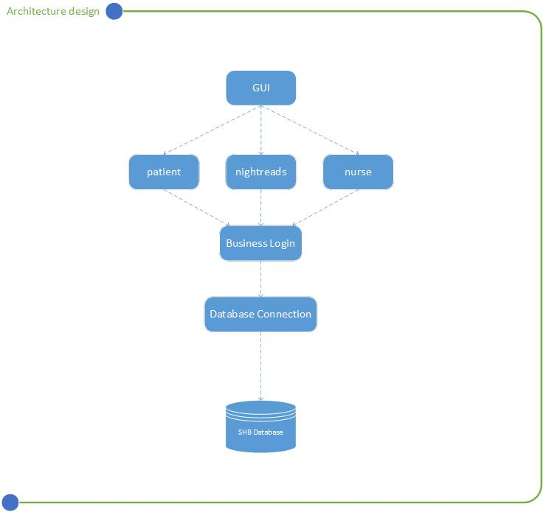

## 4.4 Algorithm for major functions

### 4.4.1 check distance

int measureFront(){

// 5v

float volts = analogRead(sensor)*0.0048828125; // value from sensor * (5/1024)

int distance = 13*pow(volts, -1); // worked out from datasheet graph

return distance; // print the distance

### }

### 4.4.2 move for ward

void MoveForward(int steps, int mspeed)

{

counter_A = 0; // reset counter A to zero

counter_B = 0; // reset counter B to zero

digitalWrite(blueRight,HIGH);

digitalWrite(blueLeft,HIGH);

// Set Motor A forward

digitalWrite(in1, HIGH);

digitalWrite(in2, LOW);

// Set Motor B forward

digitalWrite(in3, HIGH);

digitalWrite(in4, LOW);

// Go forward until step value is reached

while (steps > counter_A && steps > counter_B) {

if (steps > counter_A) {

analogWrite(enA,mspeed);

} else {

analogWrite(enA,0);

}

if (steps > counter_B) {

analogWrite(enB,mspeed);

} else {

analogWrite(enB,0);

}

}//while

// Stop when done

analogWrite(enA,0);

analogWrite(enB,0);

digitalWrite(in1, LOW);

digitalWrite(in2, LOW);

digitalWrite(in3, LOW);

digitalWrite(in4, LOW);

counter_A = 0; // reset counter A to zero

counter_B = 0; // reset counter B to zero

}//MOVE FORWARD

### 4.4.3 steps to centimeters

int CMtoSteps(float cm) {

int result; // Final calculation result

float circumference = (wheeldiameter * 3.14) / 10; // Calculate wheel circumference in cm

float cm_step = circumference / stepcount; // CM per Step

float f_result = cm / cm_step; // Calculate result as a float

result = (int) f_result; // Convert to an integer (note this is NOT rounded)

return result; // End and return result

}

## 4.5 Sample code for main functions

### 4.5.1 Glove class

/*Smart Hospital Bed (SHB).

* UNIVERSITY OF PETRA .

* Graduation project 2017/2018.

* This Code is responciable for taking reads from Gyroscope mpu 5060 Sensor and read the

* angle in which the Glove Turn to, moreover it will sends the reads to SHB to indicate the way

* its goning to turn to

* there are two buttons (Red and Green) fixwed on the glove and whenever the red is pressed the

* transmition will stop and the green will start it over.

* this Code is done by ALAA ARAB : 201411211

*/

#include "Turn.h"

// this library reads Gyroscope Data.

Turnlib turn; // Object of turn to use turn library.

bool on=false ; // to start or stop sending

//=============== SETUP METHOD=========================

void setup() {

turn.Setup(); // necessarily to setup GyroScop mpu 5060.

Serial.begin(9600); // set the baud to communicate with the SHB

pinMode(7,INPUT); // Green Button

pinMode(8,INPUT); // Red Button

pinMode(11,OUTPUT); // Green Light

pinMode(9,OUTPUT); // Red Light

}

//=================== LOOP ================================

void loop() {

if(digitalRead(7)==HIGH){on=true;} // if the Green Button is pressed.

if(digitalRead(8)==HIGH){on=false;} // if the red Button is pressed.

if(on == true){

digitalWrite(11,HIGH); // Turn on the green Light

digitalWrite(9,LOW);// Turn off the red light

//start reading from gyroscope

turn.readAngle();

}

if(on == false){

digitalWrite(9,HIGH); // Turn on the red light

digitalWrite(11,LOW); // Turn of the green light

Serial.write('7'); // Start sending '7' ... '7' here is just a random value so the care won't indicate any Order of movement.

}

}// LOOP

if((readUp()>-10 && readUp()<10) &&(readLeft()>20)){Serial.write('3');}// Turnning right

if((readUp()>-10 && readUp()<10) &&(readLeft()<-20)){Serial.write('4');}// Turnning left

if((readLeft()>-20 && readLeft()<20) &&(readUp()>20)){Serial.write('1');}// Turnning up

if((readLeft()>-20 && readLeft()<20) &&(readUp()<-20)){Serial.write('2');}// Turnning Down

if((readLeft()>-20 && readLeft()<20)&&(readUp()>-8 && readUp()<8)){Serial.write('0');}//Stop

### 4.5.2 BL Class

**<?php***/**  
 * Created by PhpStorm.  
 * User: hj  
 * Date: 8/16/2017  
 * Time: 2:43 AM  
 * All methods used to connect to the database.  
 */***require_once** "DAL.php";  
**class** BL  
{  
 **public** $dal;  
  
 */**  
 * BL constructor.  
 * used to start connection with DataBase.  
 */* **function** __construct()  
 {  
 $this->dal=**new** DAL("localhost","root","","shb");  
 }//construct  
  
  
 */**  
 * used to check the user in case of login  
 \** ***@param*** *$Email  
 \** ***@param*** *$password  
 \** ***@return*** *mixed  
 */* **public function** login($Email, $password)  
 { $sql2 = "select * from nurse WHERE Email='".$Email ."'and Password='".$password ."'";  
 **return** $result= $this->dal->executeSelect($sql2);  
 }  
  
 */**  
 * create new user and check the email  
 \** ***@param*** *$Name  
 \** ***@param*** *$Email  
 \** ***@param*** *$Password  
 \** ***@param*** *$Gender  
 \** ***@return*** *mixed  
 */* **public function** SignUp($Name, $Email, $Password, $Gender)  
 { $sql = "INSERT INTO nurse(Name,Email,Password,Gender)".  
 "VALUES ('".$Name."','".$Email."','".$Password."','".$Gender."');";  
 **return** $this->dal->executeSelect($sql);  
 }  
  
 */**  
 * add new patient  
 \** ***@param*** *$id  
 \** ***@param*** *$name  
 \** ***@param*** *$age  
 \** ***@param*** *$sex  
 \** ***@param*** *$illness  
 \** ***@return*** *mixed  
 */* **public function** addPatient($id, $name, $age, $sex, $illness)  
 {$sql= "insert into Patients VALUES(".$id.",'".$name."',".$age.",'".$sex."','".$illness."'); ";  
 **return** $this->dal->executeSelect($sql);  
 }  
  
 */**  
 * add new night reads  
 \** ***@param*** *$id  
 \** ***@param*** *$medicine  
 \** ***@param*** *$Dose  
 \** ***@return*** *mixed  
 */* **public function** addNightReads($id, $medicine, $Dose){  
 $sql="insert into nightReads (id,medicine,dose) VALUES (".$id.",'".$medicine."','".$Dose."');";  
 **return** $this->dal->executeSelect($sql);  
 }  
  
 */** check the id of the patient before adding it  
 \** ***@param*** *$id  
 \** ***@return*** *mixed  
 */* **public function** checkId($id){  
 $sql= "select id from Patients where id=".$id;  
 **return** $this->dal->executeSelect($sql);  
 }  
  
 */**  
 * this method is used to retrieve all the patient in the patients database table  
 \** ***@return*** *mixed  
 */* **public function** retrieveList(){  
 $sql = "select * from patients";  
 **return** $this->dal->executeSelect($sql);  
 }  
  
  
  
  
  
  
  
}//end class

## 4.6 Test Cases

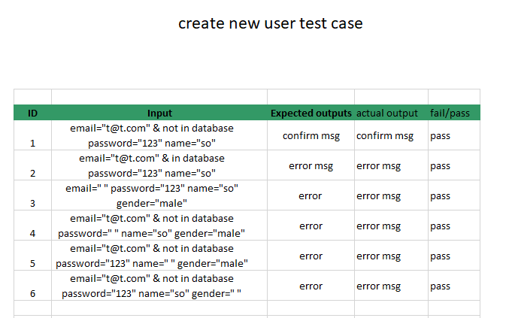

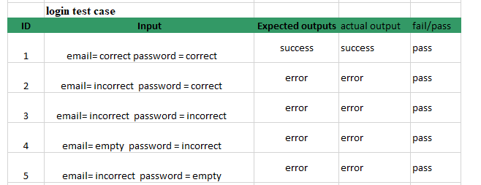

# Hardware Datasheet

## Arduino Due

Description

The Atmel↓ | SMART SAM3X/A series is a member of a family of Flash microcontrollers based on the high performance 32-bit ARM↓ Cortex↓-M3 RISC processor. It operates at a maximum speed of 84 MHz and features up to 512 Kbytes of Flash and up to 100 Kbytes of SRAM. The peripheral set includes a High Speed USB Host and Device port with embedded transceiver, an Ethernet MAC, 2 CANs, a High Speed MCI for SDIO/SD/MMC, an External Bus Interface with NAND Flash Controller (NFC), 5 UARTs, 2 TWIs, 4 SPIs, as well as a PWM timer, three 3-channel general-purpose 32-bit timers, a low-power RTC, a lowpower RTT, 256-bit General Purpose Backup Registers, a 12-bit ADC and a 12-bit DAC.

The SAM3X/A devices have three software-selectable low-power modes: Sleep, Wait and Backup. In Sleep mode, the processor is stopped while all other functions can be kept running. In Wait mode, all clocks and functions are stopped but some peripherals can be configured to wake up the system based on predefined conditions. In Backup mode, only the RTC, RTT, and wake-up logic are running. The SAM3X/A series is ready for capacitive touch thanks to the QTouch library, offering an easy way to implement buttons, wheels and sliders. The SAM3X/A architecture is specifically designed to sustain high-speed data transfers. It includes a multi-layer bus matrix as well as multiple SRAM banks, PDC and DMA channels that enable it to run tasks in parallel and maximize data throughput. The device operates from 1.62V to 3.6V and is available in 100 and 144-lead LQFP, 100-ball TFBGA and 144-ball LFBGA packages. The SAM3X/A devices are particularly well suited for networking applications:

industrial and home/building automation, gateways.

SAM3X / SAM3A Series

Atmel | SMART ARM-based MCU

DATASHEET

SAM3X / SAM3A [DATASHEET]

Atmel-11057C-ATARM-SAM3X-SAM3A-Datasheet_23-Mar-15

1. Features

Core

̶ ARM Cortex-M3 revision 2.0 running at up to 84 MHz

̶ Memory Protection Unit (MPU)

̶ Thumb↓-2 instruction set

̶ 24-bit SysTick Counter

̶ Nested Vector Interrupt Controller

● Memories

̶ 256 to 512 Kbytes embedded Flash, 128-bit wide access, memory accelerator, dual bank

̶ 32 to 100 Kbytes embedded SRAM with dual banks

̶ 16 Kbytes ROM with embedded bootloader routines (UART, USB) and IAP routines

̶ Static Memory Controller (SMC): SRAM, NOR, NAND support. NFC with 4 Kbyte RAM buffer and ECC

● System

̶ Embedded voltage regulator for single supply operation

̶ Power-on-Reset (POR), Brown-out Detector (BOD) and Watchdog for safe reset

̶ Quartz or ceramic resonator oscillators: 3 to 20 MHz main and optional low power 32.768 kHz for RTC or device

clock

̶ High precision 8/12 MHz factory trimmed internal RC oscillator with 4 MHz default frequency for fast device startup

̶ Slow Clock Internal RC oscillator as permanent clock for device clock in low-power mode

̶ One PLL for device clock and one dedicated PLL for USB 2.0 High Speed Mini Host/Device

̶ Temperature Sensor

̶ Up to 17 peripheral DMA (PDC) channels and 6-channel central DMA plus dedicated DMA for High-Speed USB Mini Host/Device and Ethernet MAC

● Low-power Modes

̶ Sleep, Wait and Backup modes, down to 2.5 µA in Backup mode with RTC, RTT, and GPBR

● Peripherals

̶ USB 2.0 Device/Mini Host: 480 Mbps, 4 Kbyte FIFO, up to 10 bidirectional Endpoints, dedicated DMA

̶ Up to 4 USARTs (ISO7816, IrDA®, Flow Control, SPI, Manchester and LIN support) and one UART

̶ 2 TWI (I2C compatible), up to 6 SPIs, 1 SSC (I2S), 1 HSMCI (SDIO/SD/MMC) with up to 2 slots

̶ 9-channel 32-bit Timer Counter (TC) for capture, compare and PWM mode, Quadrature Decoder Logic and 2-bit

Gray Up/Down Counter for Stepper Motor

̶ Up to 8-channel 16-bit PWM (PWMC) with Complementary Output, Fault Input, 12-bit Dead Time Generator

Counter for Motor Control

̶ 32-bit low-power Real-time Timer (RTT) and low-power Real-time Clock (RTC) with calendar and alarm features

̶ 256-bit General Purpose Backup Registers (GPBR)

̶ 16-channel 12-bit 1 msps ADC with differential input mode and programmable gain stage

̶ 2-channel 12-bit 1 msps DAC

̶ Ethernet MAC 10/100 (EMAC) with dedicated DMA

̶ 2 CAN Controllers with 8 Mailboxes

̶ True Random Number Generator (TRNG)

̶ Register Write Protection

● I/O

̶ Up to 103 I/O lines with external interrupt capability (edge or level sensitivity), debouncing, glitch filtering and ondie

Series Resistor Termination

̶ Up to six 32-bit Parallel Input/Outputs (PIO)

SAM3X / SAM3A [DATASHEET] 3

Atmel-11057C-ATARM-SAM3X-SAM3A-Datasheet_23-Mar-15

● Packages

̶ 100-lead LQFP – 14 x 14 mm, pitch 0.5 mm

̶ 100-ball TFBGA – 9 x 9 mm, pitch 0.8 mm

̶ 144-lead LQFP – 20 x 20 mm, pitch 0.5 mm

̶ 144-ball LFBGA – 10 x 10 mm, pitch 0.8 mm

1.1 Configuration Summary

The SAM3X/A series devices differ in memory sizes, package and features list. Table 1-1 summarizes the

configurations.

Notes: 1. 4 Kbytes RAM buffer of the NFC which can be used by the core if not used by the NFC

2. One channel is reserved for internal temperature sensor

3. Six TC channels are accessible through PIO

4. Three TC channels are accessible through PIO

5. USART3 in UART mode (RXD3 and TXD3 available)

6. Available only on SAM3X8H in LFBGA217 package, which is mounted on SAM3X-EK evaluation kit for SAM3X and SAM3A

series. The SAM3X8H device is not commercially available.

## Arduino uno

Overview

The Arduino Uno is a microcontroller board based on the ATmega328 (datasheet). It has 14 digital input/output pins (of which 6 can be used as PWM outputs), 6 analog inputs, a 16 MHz ceramic resonator, a USB connection, a power jack, an ICSP header, and a reset button. It contains everything needed to support the microcontroller; simply connect it to a computer with a USB cable or power it with a AC-to-DC adapter or battery to get started. The Uno differs from all preceding boards in that it does not use the FTDI USB-to-serial driver chip. Instead, it features the Atmega16U2 (Atmega8U2 up to version R2) programmed as a USB-to-serial converter. Revision 2 of the Uno board has a resistor pulling the 8U2 HWB line to ground, making it easier to put into DFU mode. Revision 3 of the board has the following new features: • 1.0 pinout: added SDA and SCL pins that are near to the AREF pin and two other new pins placed near to the RESET pin, the IOREF that allow the shields to adapt to the voltage provided from the board. In future, shields will be compatible both with the board that use the AVR, which operate with 5V and with the Arduino Due that operate with 3.3V. The second one is a not connected pin, that is reserved for future purposes. • Stronger RESET circuit. • Atmega 16U2 replace the 8U2. "Uno" means one in Italian and is named to mark the upcoming release of Arduino 1.0. The Uno and version 1.0 will be the reference versions of Arduino, moving forward. The Uno is the latest in a series of USB Arduino boards, and the reference model for the Arduino platform; for a comparison with previous versions, see the index of Arduino boards.

Summary

Microcontroller ATmega328

Operating Voltage 5V

Input Voltage (recommended) 7-12V

Input Voltage (limits) 6-20V

Digital I/O Pins 14 (of which 6 provide PWM output)

Analog Input Pins 6

DC Current per I/O Pin 40 mA

DC Current for 3.3V

Pin 50 mA Flash Memory 32 KB (ATmega328) of which 0.5 KB used by bootloader

SRAM 2 KB (ATmega328) EEPROM 1 KB (ATmega328)

Clock Speed 16 MHz

Schematic & Reference Design

EAGLE files: arduino-uno-Rev3-reference-design.zip (NOTE: works with Eagle 6.0 and newer) Schematic: arduino-uno-Rev3-schematic.pdf Note: The Arduino reference design can use an Atmega8, 168, or 328, Current models use an ATmega328, but an Atmega8 is shown in the schematic for reference. The pin configuration is identical on all three processors.

## Arduino nano

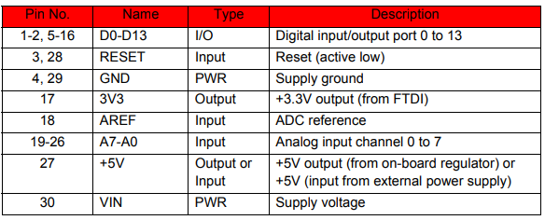

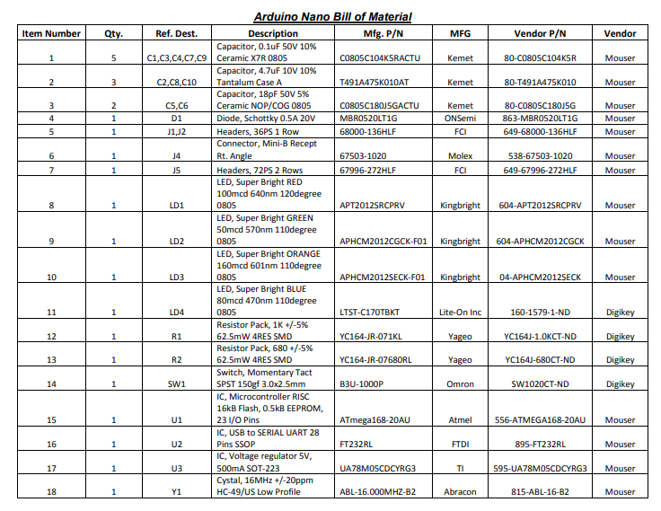

## MPU 6050 Gyroscope

Features

5.1 Gyroscope Features

The triple-axis MEMS gyroscope in the MPU-60X0 includes a wide range of features:

• Digital-output X-, Y-, and Z-Axis angular rate sensors (gyroscopes) with a user-programmable fullscale

range of ±250, ±500, ±1000, and ±2000°/sec

• External sync signal connected to the FSYNC pin supports image, video and GPS synchronization

• Integrated 16-bit ADCs enable simultaneous sampling of gyros

• Enhanced bias and sensitivity temperature stability reduces the need for user calibration

• Improved low-frequency noise performance

• Digitally-programmable low-pass filter

• Gyroscope operating current: 3.6mA

• Standby current: 5µA

• Factory calibrated sensitivity scale factor

• User self-test

Accelerometer Features

The triple-axis MEMS accelerometer in MPU-60X0 includes a wide range of features:

• Digital-output triple-axis accelerometer with a programmable full scale range of ±2g, ±4g, ±8g and

±16g

• Integrated 16-bit ADCs enable simultaneous sampling of accelerometers while requiring no external

multiplexer

• Accelerometer normal operating current: 500µA

• Low power accelerometer mode current: 10µA at 1.25Hz, 20µA at 5Hz, 60µA at 20Hz, 110µA at

40Hz

• Orientation detection and signaling

• Tap detection

• User-programmable interrupts

• High-G interrupt

• User self-tes

Additional Features

The MPU-60X0 includes the following additional features:

• 9-Axis MotionFusion by the on-chip Digital Motion Processor (DMP)

Auxiliary master I2C bus for reading data from external sensors (e.g., magnetometer)

• 3.9mA operating current when all 6 motion sensing axes and the DMP are enabled

• VDD supply voltage range of 2.375V-3.46V

• Flexible VLOGIC reference voltage supports multiple I

2C interface voltages (MPU-6050 only)

• Smallest and thinnest QFN package for portable devices: 4x4x0.9mm

• Minimal cross-axis sensitivity between the accelerometer and gyroscope axes

• 1024 byte FIFO buffer reduces power consumption by allowing host processor to read the data in

bursts and then go into a low-power mode as the MPU collects more data

• Digital-output temperature sensor

• User-programmable digital filters for gyroscope, accelerometer, and temp sensor

• 10,000 g shock tolerant

• 400kHz Fast Mode I2C for communicating with all registers

• 1MHz SPI serial interface for communicating with all registers (MPU-6000 only)

• 20MHz SPI serial interface for reading sensor and interrupt registers (MPU-6000 only)

## BLUETOOTH HC-06

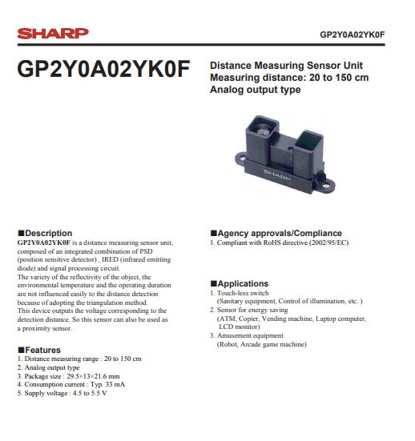

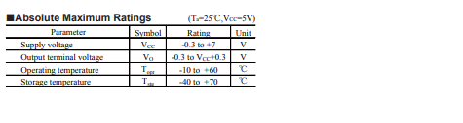

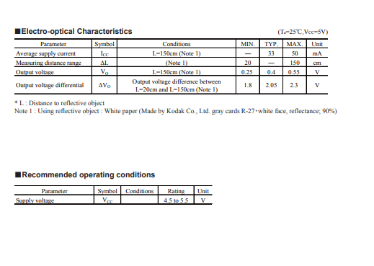

## Ultrasonic sensor

● Product features:

Ultrasonic ranging module HC - SR04 provides 2cm - 400cm non-contact

measurement function, the ranging accuracy can reach to 3mm. The modules

includes ultrasonic transmitters, receiver and control circuit. The basic principle

of work:

(1) Using IO trigger for at least 10us high level signal,

(2) The Module automatically sends eight 40 kHz and detect whether there is pulse signal back.

(3) IF the signal back, through high level , time of high output IO duration I The time from sending ultrasonic to returning Test distance = (high level time×velocity of sound (340M/S) / 2,

Wire connecting direct as following:

* 5V Supply
* Trigger Pulse Input
* Echo Pulse Output
* 0V Ground

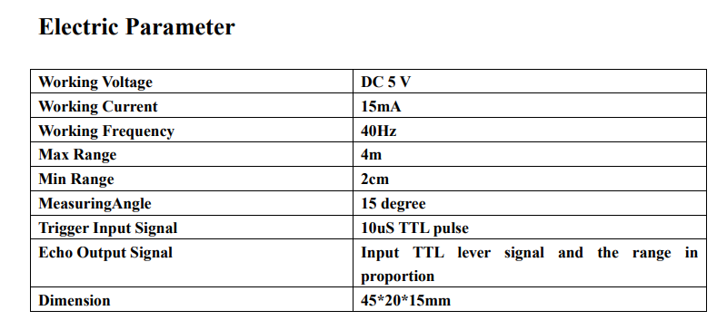

# References

*flexbed*. (2018, march 20). Retrieved from /ieeexplore.ieee.org: http://ieeexplore.ieee.org/document/6879265/

Hughes, C. (2016). what is a Robot? In C. Hughes, *Robot Programming: A Guide to Controlling Autonomous Robots.*

*lm393 datasheets*. (2018, march 24). Retrieved from arduino: http://www.store.arduino.cc/datasheets/393lm

*mega* . (2018, march 16). Retrieved from arduino: www.store.arduino.cc/datasheets

Overview. (2014). In G. A. Bekey, *Autonomous Robots.*

*what-autonomous-robots*. (2018, March 20). Retrieved from waypointrobotics.com: https://waypointrobotics.com/blog/what-autonomous-robots/